ACCESS PACK
Multiple Bad Things
29 May – 9 June 2024

VISUAL GUIDE: MALTHOUSE THEATRE
113 STURT STREET SOUTHBANK VIC 3006
GENERAL INFORMATION

MULTIPLE BAD THINGS is theatre. It is not real. But in a world where self-righteously indignant voices so often drown out the most disenfranchised and vulnerable, this theatre sometimes feels real.
At a time like this, in a placeless warehouse at the end of the world, three employees approach a possibly futile task. Struggling to work together, they grapple with questions of inclusion and equity. They are forced to test the limits of their bodies, their cooperation, and their capacity to care. Civility slips, bad behaviour escalates, and reality distorts.
Back to Back Theatre is a global leader for challenging the assumptions of what is possible on the stage, and in ourselves. For over 30 years, their ensemble of performers has created epic and arresting theatre that weaves together the personal, political, and cosmic.
Known for groundbreaking productions that tour the world—Ganesh Versus The Third Reich, Small Metal Objects—MULTIPLE BAD THINGS is their latest.
In the making of this new work, Back to Back Theatre invites new voices into the devising room. Zoë Barry’s score is assembled from collected field recordings of bad things. Anna Cordingley’s design dem
ands the actors’ physical participation to reach its manifestation.
DETAIL
New Work, Melbourne Premiere

Dates: 29 May – 9 June 2024

Duration: 60 minutes
Relaxed Performance: No dedicated relaxed performance, please talk to our Front of House or Box Office Team if you require assistance.

Venue: Merlyn Theatre, The Malthouse, 113 Sturt Street, Southbank VIC 3006

Company Website: https://www.malthousetheatre.com.au/

Malthouse Theatre Access Webpage: https://www.malthousetheatre.com.au/your-visit/access/

Multiple Bad Things Event Page: https://www.malthousetheatre.com.au/what-s-on/malthouse-theatre/multiple-bad-things/

THE ARTISTS

DEVISORS / Bron Batten, Breanna Deleo, Natasha Jynel, Simon Laherty, Sarah Mainwaring, Ben Oakes, Scott Price, Tamara Searle, Ingrid Voorendt
DIRECTORS / Tamara Searle, Ingrid Voorendt
CAST / Bron Batten, Simon Laherty, Sarah Mainwaring, Scott Price
COMPOSER & SOUND DESIGNER / Zoë Barry
SET & COSTUME DESIGNER / Anna Cordingley
LIGHTING DESIGNER / Richard Vabre
AV DESIGNER / Rhian Hinkley
HELPLINE VOICEOVER / Rachel Griffiths
SCRIPT CONSULTANT / Melissa Reeves
CREATIVE DEVELOPMENT / Michael Chan, Mark Deans, Alana Hoggart, Francesca Neri, Tamika Simpson
SET CONSTRUCTION / Kinetic Sets
SCREEN CONSTRUCTION / Reveal Productions
SCENIC ART / Patrick Jones
STAGE MANAGER / Alana Hoggart
PRODUCTION ASSOCIATE / Jordi Edwards
SOUND ENGINEER / Peter Monks

LIST OF CONTENT WARNINGS

Adult Themes, Coarse Language, Partial Nudity, Sexual References

HOW TO BOOK / CONTACT US

Information about The Malthouse venue and Multiple Bad Things can be found on Malthouse Theatre’s website www.malthousetheatre.com.au

You can book tickets on the website or by calling the Box Office on (03) 9685 5111.

For more detailed access information, please feel free to contact our box office team on: boxoffice@malthousetheatre.com.au

We are committed to continual improvement and learning and welcome your feedback.

HOW TO GET TO THE MALTHOUSE
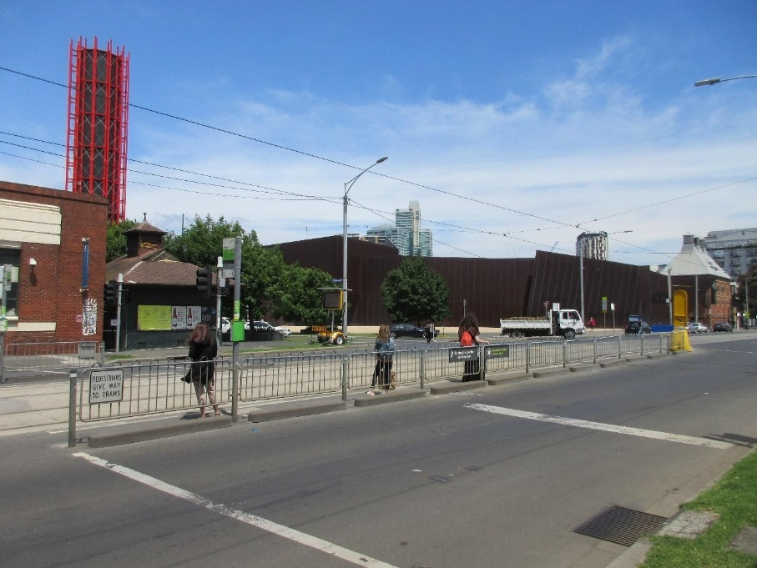
Pictured: The view of Stop 18 with Malthouse and ACCA in the distance
The Malthouse is located at 113 Sturt Street in Southbank. You can get here by tram, train, bike or car.

Tram: The closest tram stop is Stop 18 – Grant Street/Sturt Street (Route 1). You can also get to the venue from St Kilda Road. Get off at Stop 17 – Grant Street, Police Memorial/St Kilda Road. From this stop, it is a 6-minute walk to the venue via Grant Street.

Train: Flinders Street station is approximately 15-minute walk away.

Bike: There are bike racks and a Melbourne Bike Share station outside The Malthouse.

Car: There is limited on-street parking on Grant Street, Sturt Street and Dodds Street. There are 2 disabled spaces outside The Malthouse entrance on Sturt Street.

The closest secure carparks are:
- Arts Centre Melbourne Car Park (enter from Sturt Street)
- The Australian Ballet Centre Car Park (2 Kavanagh Street)

VENUE IMAGES
Entrance from Sturt Street side
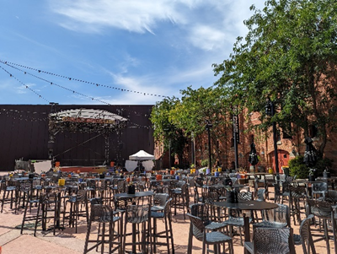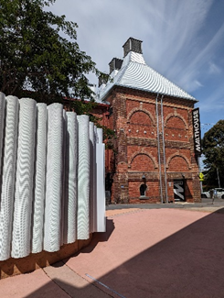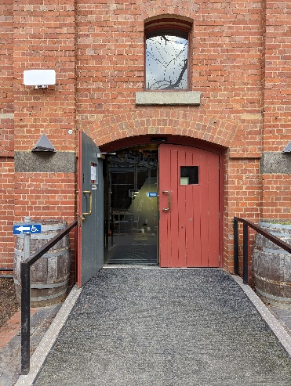

Entrance from Dodds Street side (wheelchair access)
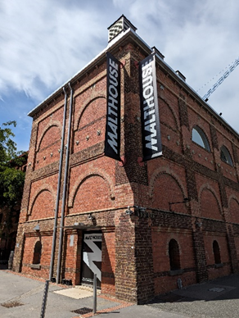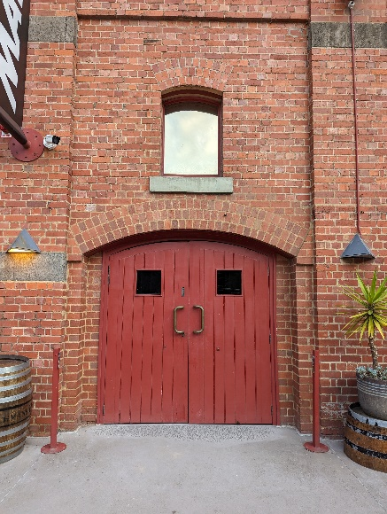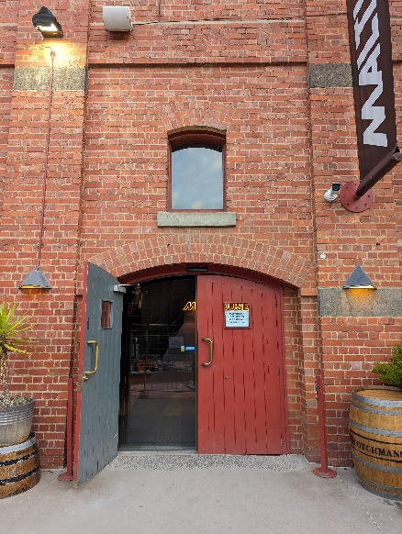

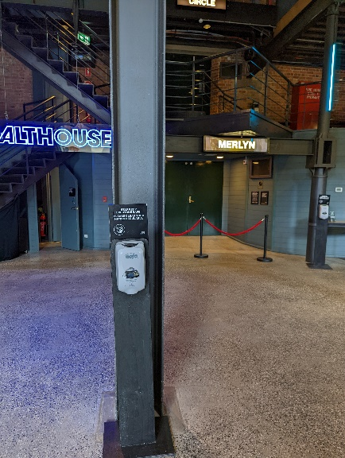
Sanitiser station in the Foyer
Bar and seating in the Foyer
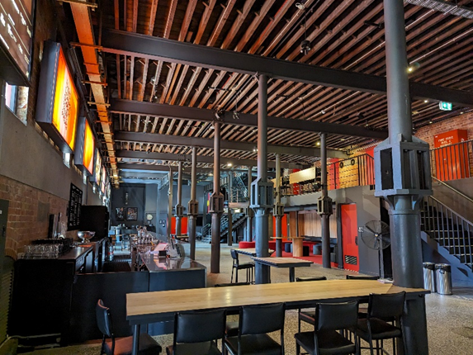
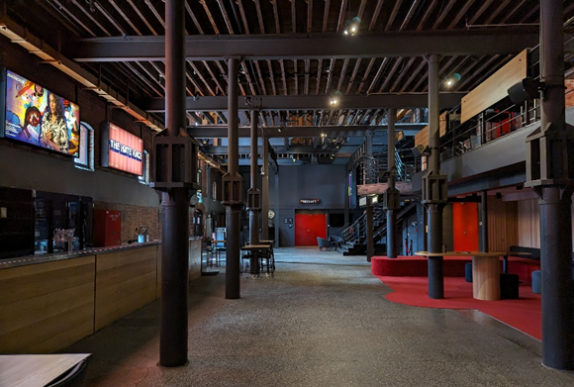

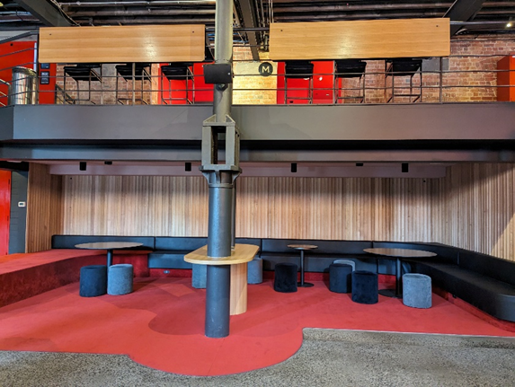

Box Office in the Foyer
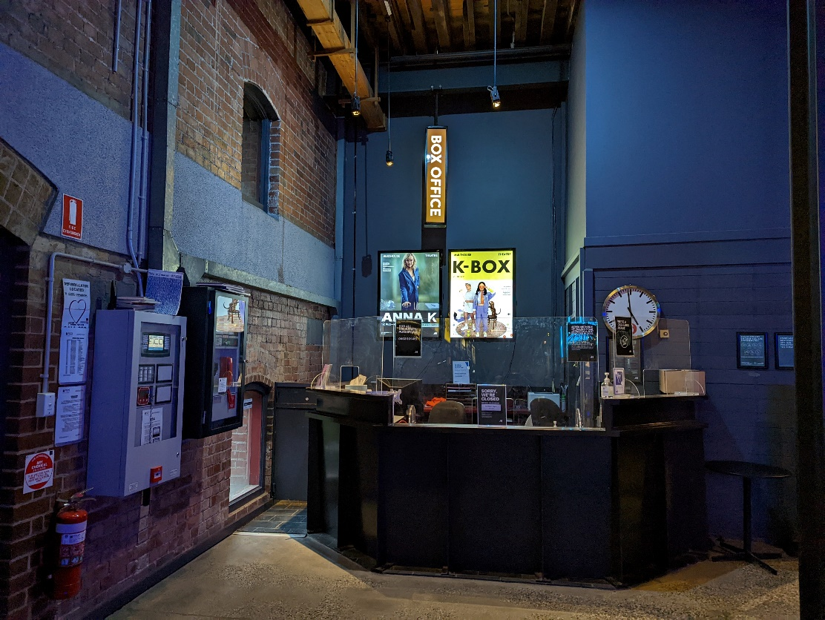

Bathroom in Foyer (Ground Level)

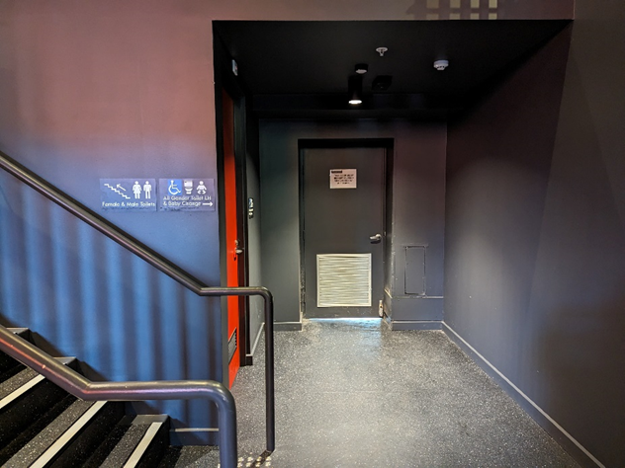
All gender toilet, Baby Change

Bathrooms on Mezzanine (up a flight of stairs)

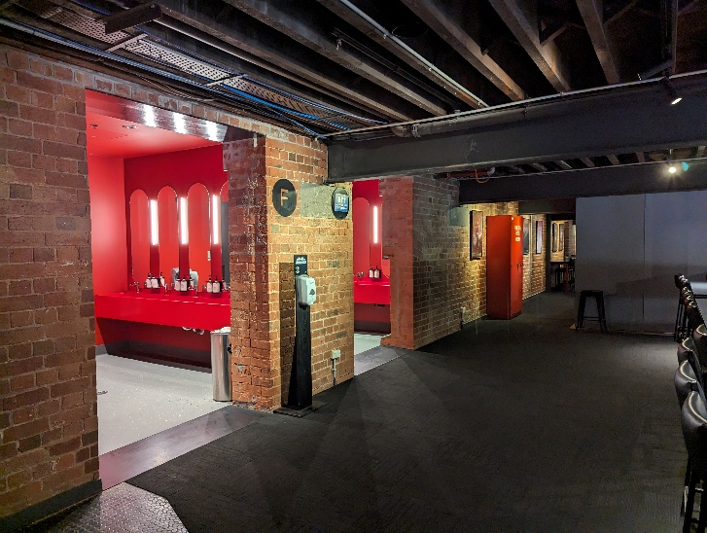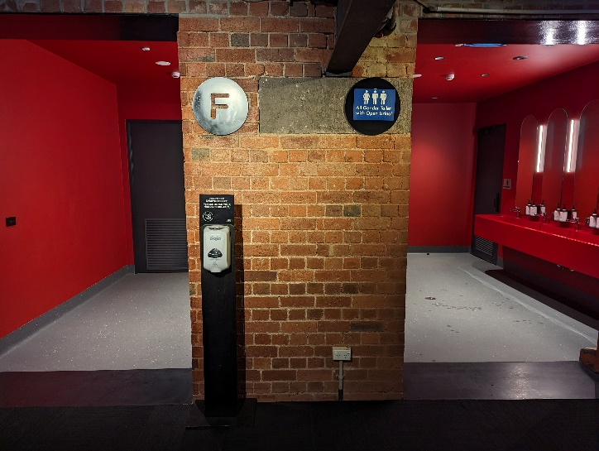

Merlyn Theatre entrance

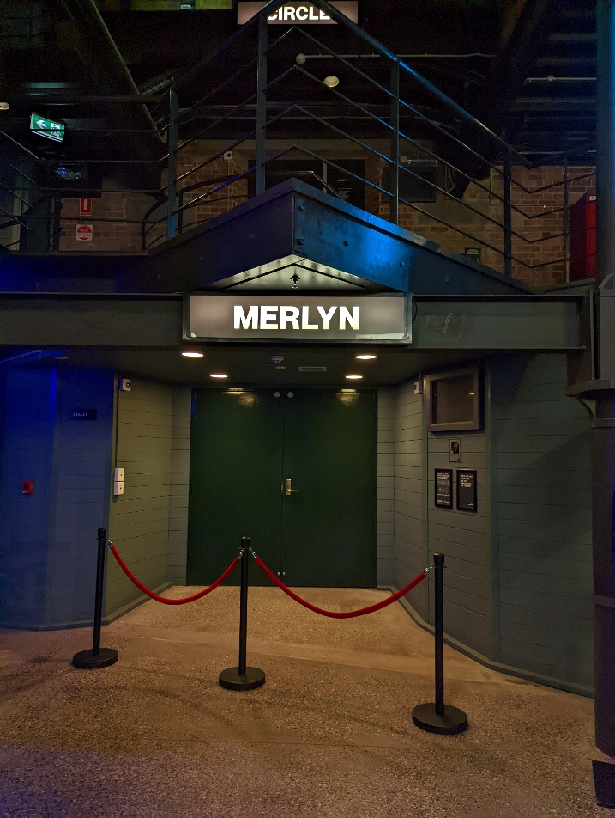
This entrance is wheelchair accessible.

THEATRES
The Malthouse has three theatres, The Merlyn, The Beckett and the Tower Theatre. Multiple Bad Things is playing in the Merlyn Theatre.

All theatres and spaces at the Malthouse are clearly marked. There are many staff members who will be able to assist you if you have any questions.

Below is a picture of inside the Merlyn Theatre, the seats are in L configuration. 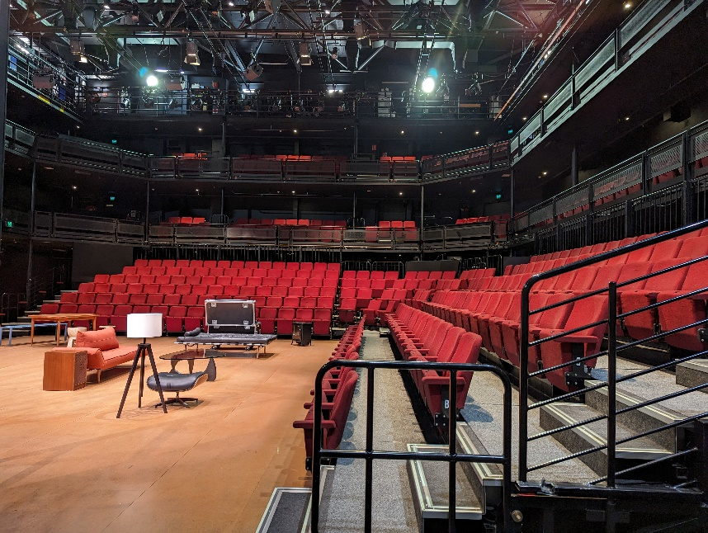

The theatre seats are organized in rows, labelled with letters from AAA to M. Each seat also has a number on it. Your ticket will show which row and seat number you can sit in.

Pictured: theatre seats with number labels

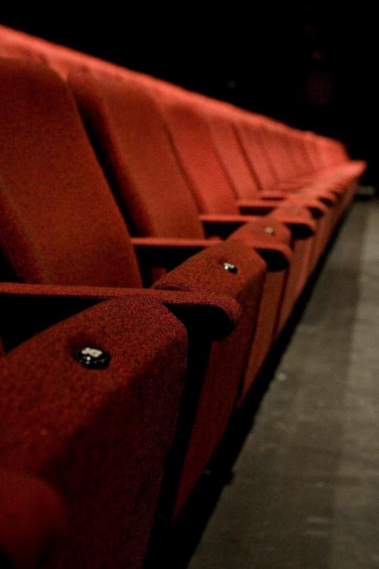

WE’RE HERE TO ASSIST
If you need help finding your seat, or with anything else, you can ask a Malthouse Theatre Usher. Ushers wear a uniform of a black shirt with a lanyard.
Pictured: Usher wearing their uniform.

