**ACCESS PACK**

***Apologia***

**6 – 18 August 2024**

**VISUAL GUIDE: MALTHOUSE THEATRE**

**113 STURT STREET SOUTHBANK VIC 3006**

**GENERAL INFORMATION**

Indulge in Nicola Gunn’s personal fantasy of being a French actress - despite being categorically not French. In a series of surreal comedic encounters a French actress is fired for her bad behaviour, two tourists find themselves disappointed by the city of Paris and a French translator attempts to navigate the complex relationship with her mother and her mother tongue. ***Apologia*** fuses comedy with awkward attempts to express ourselves and communicate across boundaries. Armed with her signature bold and candid approach, **Nicola Gunn** (*Piece For Person and Ghetto Blaster*) confronts what it means to have your voice translated by others.

**DETAIL**

World Premiere, New Work

**Dates:** 6 – 18 August 2024

**Duration:** 80 minutes

**Relaxed Performance:** No dedicated relaxed performance, please talk to our Front of House or Box Office Team if you require assistance.

**Venue:** Beckett Theatre, The Malthouse, 113 Sturt Street, Southbank VIC 3006

**Company Website:** <https://www.malthousetheatre.com.au/>

**Malthouse Theatre Access Webpage**: <https://www.malthousetheatre.com.au/your-visit/access/>

**Event Page:** <https://www.malthousetheatre.com.au/what-s-on/malthouse-theatre/apologia/>

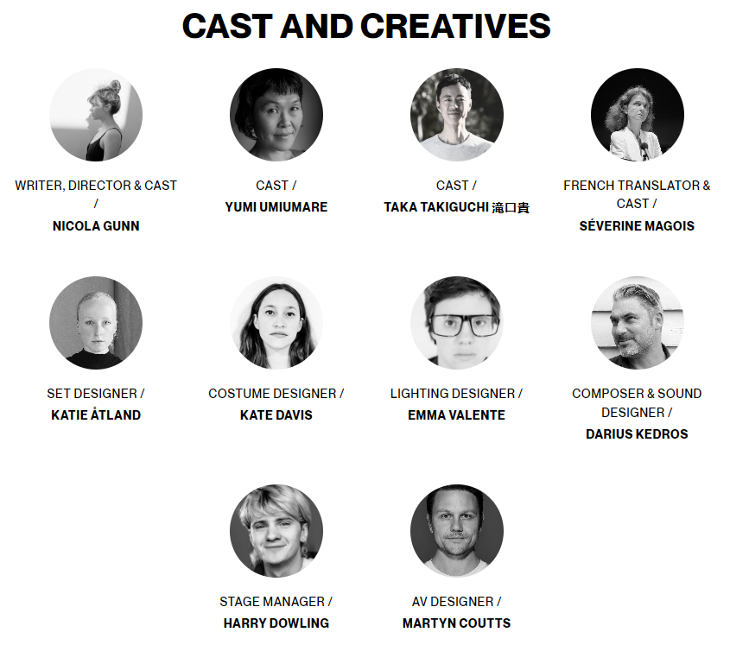  
WRITER, DIRECTOR & CAST / Nicola Gunn

CAST / Yumi Umiumare

CAST / Taka Takiguchi 滝口貴

FRENCH TRANSLATOR & CAST / Séverine Magois

SET DESIGNER / Katie Åtland

COSTUME DESIGNER / Kate Davis

LIGHTING DESIGNER / Emma Valente

COMPOSER & SOUND DESIGNER / Darius Kedros

STAGE MANAGER / Harry Dowling

AV DESIGNER / Martyn Coutts  
JAPANESE TRANSLATOR / Aoi Matsushim

ADDITIONAL JAPANESE TRANSLATION / TAKA TAKIGUCHI 滝口貴 & YUMI UMIUMARE

AV DESIGN INTERN / RUBI DINARDO

STAGE MANAGEMENT INTERN / MAISY BUTCHART

**LIST OF CONTENT WARNINGS**

This production contains strobe and flashing lights, coarse language, loud music, theatrical haze/fog, herbal cigarette smoking, and references to death and dying, and features partial English translation surtitles of performers’ dialogue and other uses of visual text.

Please note: this performance is not surtitled in full. For information about access services, or assistance with booking, please email boxoffice@malthousetheatre.com.au or call (03) 9685 5111.

**HOW TO BOOK / CONTACT US**

Information about The Malthouse venue and *Apologia* can be found on Malthouse Theatre’s **website** [www.malthousetheatre.com.au](http://www.malthousetheatre.com.au)

You can book tickets on the website or by calling the **Box Office** on (03) 9685 5111.

For more detailed access information, please feel free to contact our box office team on: [boxoffice@malthousetheatre.com.au](mailto:boxoffice@malthousetheatre.com.au)

We are committed to continual improvement and learning and welcome your feedback.

**HOW TO GET TO THE MALTHOUSE**

*Pictured: The view of Stop 18 with Malthouse and ACCA in the distance* 

The Malthouse is located at 113 Sturt Street in Southbank. You can get here by tram, train, bike or car.

**Tram:** The closest tram stop is Stop 18 – Grant Street/Sturt Street (Route 1). You can also get to the venue from St Kilda Road. Get off at Stop 17 – Grant Street, Police Memorial/St Kilda Road. From this stop, it is a 6-minute walk to the venue via Grant Street.

**Train:** Flinders Street station is approximately 15-minute walk away.

**Bike:** There are bike racks and a Melbourne Bike Share station outside The Malthouse.

**Car:** There is limited on-street parking on Grant Street, Sturt Street and Dodds Street. There are 2 disabled spaces outside The Malthouse entrance on Sturt Street.

The closest secure carparks are:

* Arts Centre Melbourne Car Park (enter from Sturt Street)
* The Australian Ballet Centre Car Park (2 Kavanagh Street)

**VENUE IMAGES**  
  
Entrance from Sturt Street side

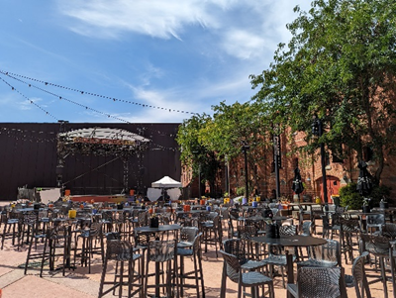 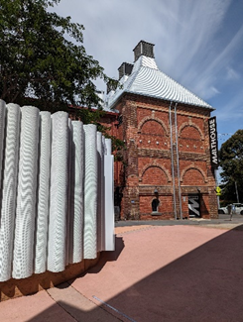

Entrance from Dodds Street side (wheelchair access)

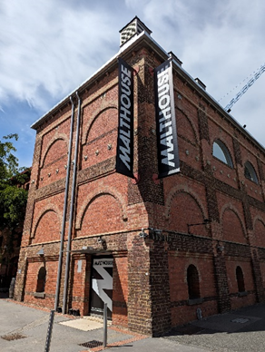

Bar and seating in the Foyer

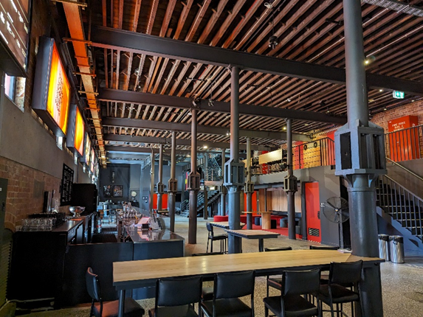

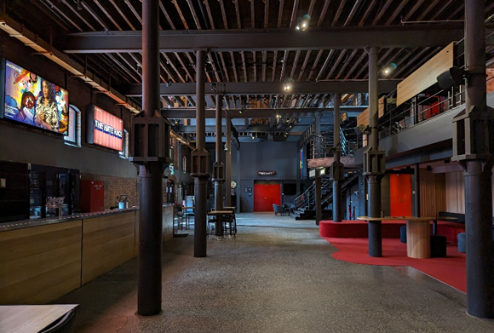

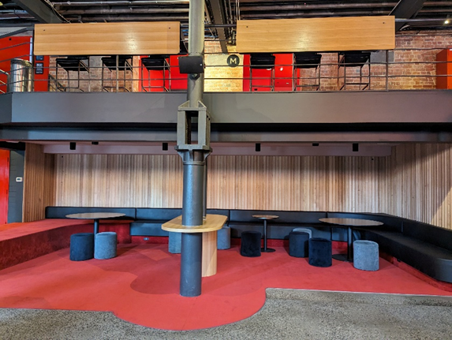

Box Office in the Foyer

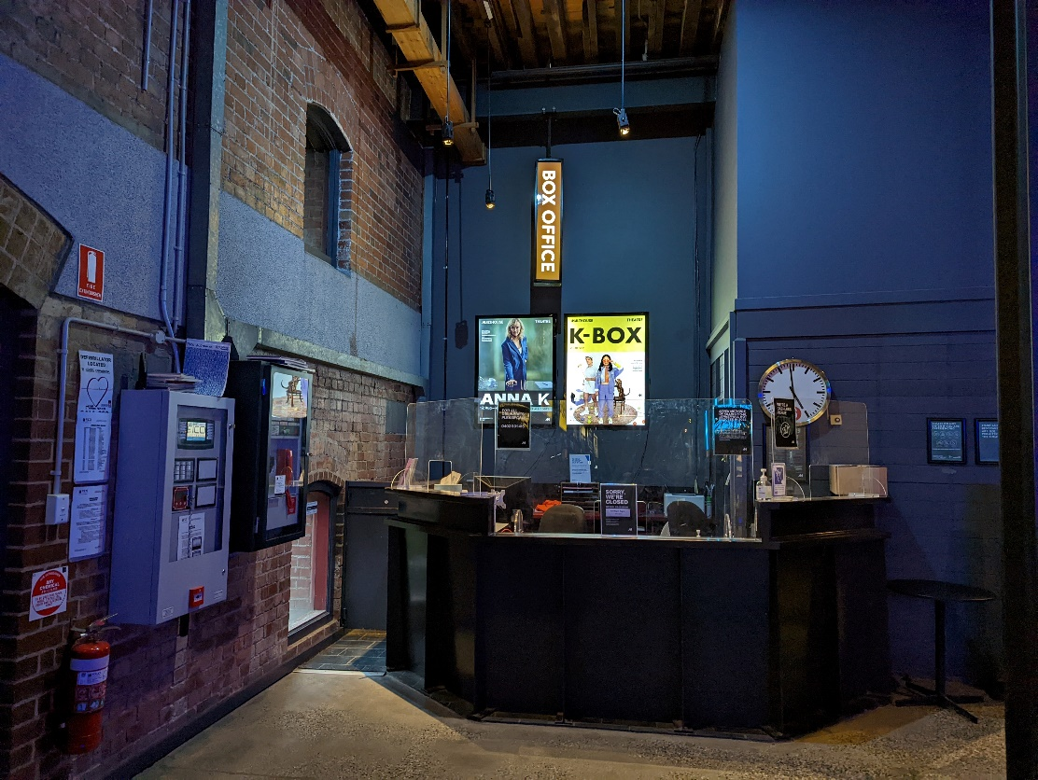

Bathroom in Foyer (Ground Level)

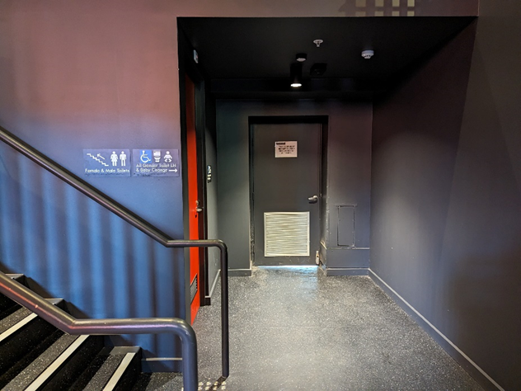

*All gender toilet, Baby Change*

Bathrooms on Mezzanine (up a flight of stairs)

**THEATRES**

The Malthouse has three theatres, The Merlyn, The Beckett and the Tower Theatre.

All theatres and spaces at the Malthouse are clearly marked. There are many staff members who will be able to assist you if you have any questions.

**Merlyn Theatre entrance**

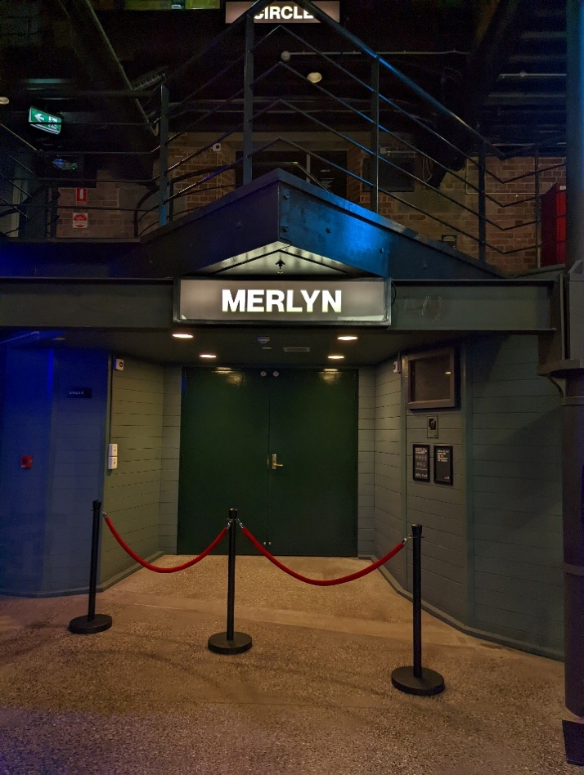

*This entrance is wheelchair accessible.*

*Below is a picture of inside the Merlyn Theatre*, the seats are not always in this configuration. 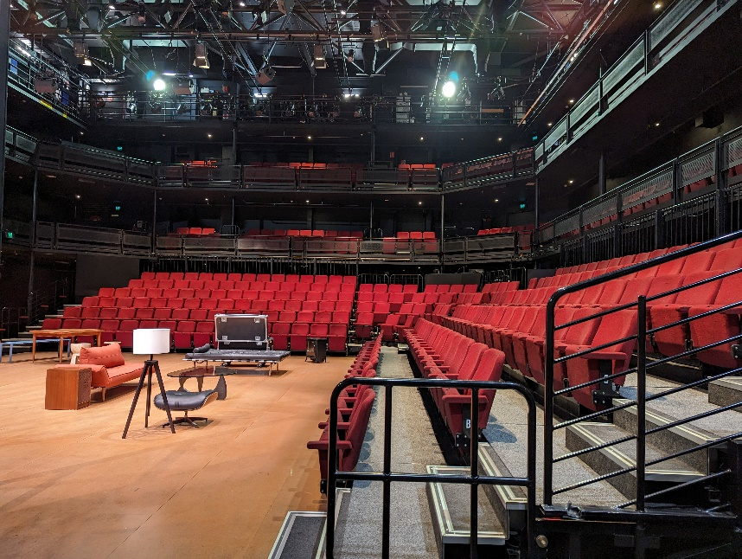

The theatre seats are organized in rows, labelled with letters from AAA to M. Each seat also has a number on it. Your ticket will show which row and seat number you can sit in.

Pictured: theatre seats with number labels

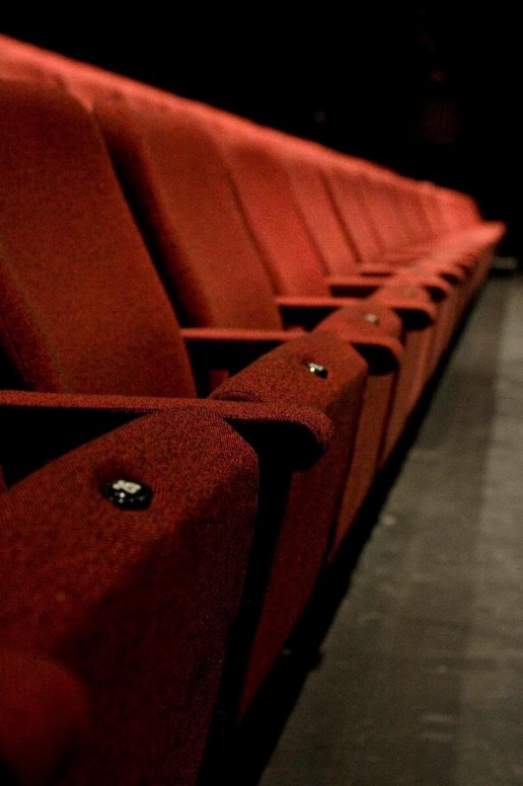

**Beckett Theatre entrance**

This entrance is wheelchair accessible.

*Below is a picture of inside the Beckett Theatre*

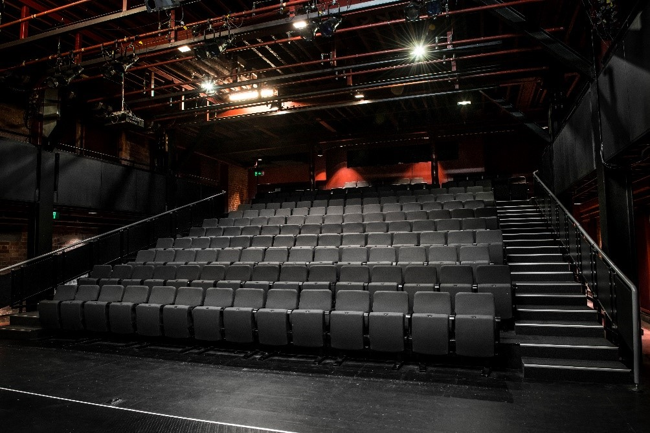

The theatre seats are organized in rows, labelled with letters from A to M. Each seat also has a number on it. Your ticket will show which row and seat number you can sit in.

Pictured: theatre seats with number labels

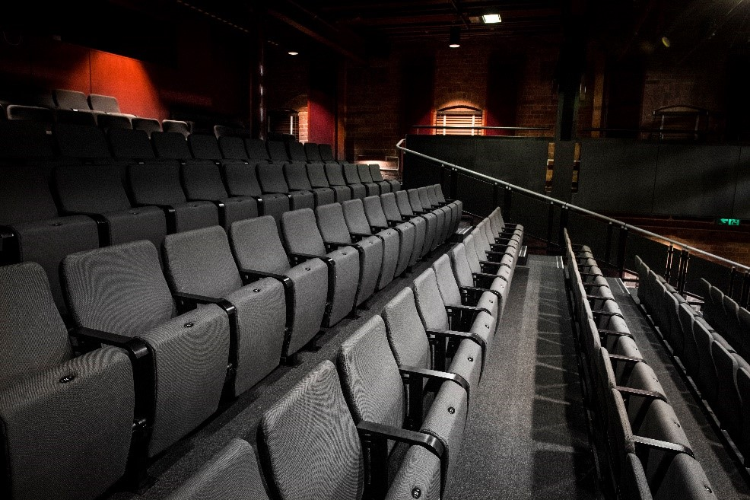

**WE’RE HERE TO ASSIST**

If you need help finding your seat, or with anything else, you can ask a Malthouse Theatre Usher. Ushers wear a uniform of a black shirt with a lanyard.

**Pictured:** Usher wearing their uniform.