Access Guide:

Telethon Kid

by Alistair Baldwin

Malthouse Theatre
July 28 – August 13

Last updated Wednesday 2nd August

Table of Contents
GENERAL INFORMATION 4
Where 4
When 4
Previews 4
Opening night 4
Season 4
Length 5
How to book 5
Auslan Interpretation 5
Audio Description 5
Relaxed Performance 5
Wheelchair Access 6
Companion Cards: 6
Assisted Listening System 6
Identifying Front of House Staff 6
Access Contact 7
Feedback 7
GETTING TO MALTHOUSE THEATRE 8
Getting here by tram 8
Car drop-off 9
Accessible Taxi drop-off 10
Parking: 12
VENUE ACCESS 13
Entrances 13
Sturt St Entrance 14
Dodds St / DDA Compliant Entrance 16
Foyer 18
Box Office 19
Bar 20
Koyzina Café 21
Bathrooms 22
Accessible bathroom 22
Ambulant, female and all gendered bathrooms 22
The Beckett Theatre 23
Quiet space 26
INFORMATION ABOUT THE SHOW 28
Sensory information 28
Sound design 28
Lighting design 28
Dialogue 28
Projections 28
Reflective objects 29
Busy patterns on costumes 29
Content warnings and notes 29
Frequent coarse and derogatory language 29
Sexual intimacy between consenting adults and partial nudity 29
Frequent discussion of disability, chronic pain and chronic illness 30
Frequent depictions of ableism 30
Frequent depictions of medial and hospital imagery, devices and treatments 31
Discussion of grooming and medical consent 31
References to death, dying and mortality 31
References to sexual assault 31
Depictions of alcohol consumption 31
Depiction of a medical procedure 32
References to drug consumption 32

GENERAL INFORMATION
This access guide has been prepared by Loom Arts and Management on behalf of Malthouse Theatre. The implementation of recommendations delivered by Loom’s consultants are the sole responsibility of Malthouse Theatre.

Where
Beckett Theatre, The Malthouse, 113 Sturt Street, Southbank VIC 3006

When

Previews
7pm Friday 28th July
7pm Saturday 29th July
7pm Monday 30th July
7pm Tuesday 1st August

Opening night
7pm Wednesday 2nd August

Season
7pm Thursday 3rd August
7pm Friday 4th August (Auslan Interpreted & Audio Described + Takeover Night)
1:30pm Saturday 5th August
7pm Saturday 5th August
7pm Sunday 6th August
7pm Tuesday 8th August (Auslan Interpreted + Time to Talk)
7pm Wednesday 9th August (Audio Described)
7pm Thursday 10th August
7pm Friday 11th August
1:30pm Saturday 12th August (Relaxed Performance)
7pm Saturday 12th August
7pm Sunday 13th August

Length
Approximately 85 minutes

How to book
You can book tickets on the Malthouse website here: https://www.malthousetheatre.com.au/tickets/malthouse-theatre/telethon-kid/#eventTarget
You can also book tickets by calling the Box Office on (03) 9685 5111.

Auslan Interpretation
Auslan Interpretation will be available on Friday 4th and Tuesday 8th of August at 7pm. Please use the code AUSLAN on the ticket booking page to receive a discounted ticket online or call the Box Office on (03) 9685 5111.

Audio Description
Audio description will be available on Friday 4th and Wednesday 9th of August at 7pm. Please use the code AUDIO on the ticket booking page to receive a discounted ticket online or call the Box Office on (03) 9685 5111.

Relaxed Performance
A relaxed version of the show will be performed on Saturday 12th August at 1:30pm. Lighting and sound elements will be adjusted for this performance to make it more accessible to members of the community with sensory sensitivities. Moving around and stimming is welcome during this show and house lights will remain partially up. Audience members will be briefed on this before entering. A quiet space will be available on Level 2.

Wheelchair Access
The Malthouse is a wheelchair accessible venue with an accessible bathroom with grab rails on the ground floor. Please note that this bathroom is currently undergoing an upgrade and whilst DDA compliant, is a temporary fixture.
Wheelchair space in the audience can be reserved when booking online or by calling the Box Office on (03) 9685 5111.

Companion Cards:
Companion Card tickets may be booked free of charge by calling the Box Office on (03) 9685 5111. You will need to bring your companion card with you and may be asked to show it to either Box Office or Front of House Staff.

Assisted Listening System
Malthouse offers an Assisted Listening System which allows patrons using a hearing aid to tune into the frequency of that venue. For patrons without a hearing aid, they offer a similar system and provide the patron with headphones. Please see a Front of House Staff member on arrival if you would like to make use of this service.

Identifying Front of House Staff
Malthouse’s friendly Front of House Staff are here to help you with anything you need. They will be present in the foyer before the show and will collect your tickets when you go into the theatre and help you find your seat. If you require any assistance when you arrive or during your visit, please feel free to approach them. They will be dressed in black and will be wearing a black and white Malthouse lanyard.

Image description: A photo of Mitchell, a Front of House Staff member, smiling and standing in front of a light grey wall. He has long curly brown hair and a beard and is wearing a black t-shirt with a lanyard around his neck. The lanyard is black with white text which reads: MALTHOUSE.

Access Contact
For more detailed access information, please feel free to contact Zoe Boesen by phone: 0402 331 448 or via email: zoe@loom.org.au

Feedback
We are committed to continual improvement and learning and welcome your feedback. Please feel free to contact Zoe Boesen by phone: 0402 331 448 or via email: zoe@loom.org.au with any feedback about your experience accessing this performance. You are welcome to give your feedback anonymously.

GETTING TO MALTHOUSE THEATRE

Malthouse Theatre is located at 113 Sturt Street in Southbank. The Malthouse is located between Grant St and Miles St and is closest to the Grant St corner.
Google Maps link: Malthouse Theatre
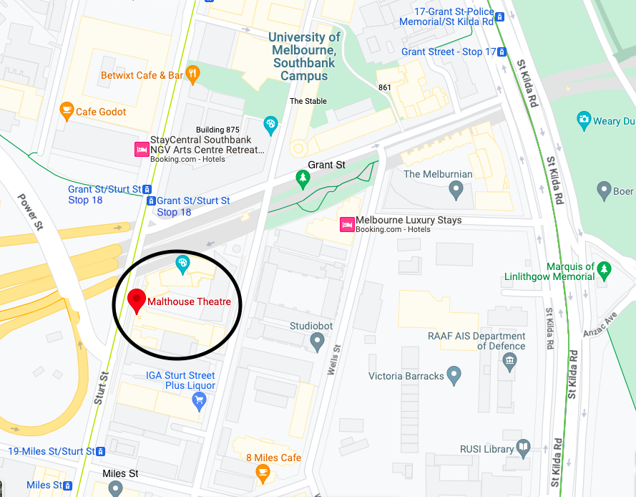
Image description: A computer screen shot of a map showing Malthouse Theatre circled in black.

Getting here by tram
The Malthouse Theatre is on the southbound traffic side of Sturt St or the left-hand side of the road if travelling away from Flinders St Station.
The closest tram stop is the Grant St / Sturt St Stop 18 of the number 1 tram. The Malthouse is approximately 85m south of this stop. Please note this stop does not have level access.
The Malthouse is 600m from Grant St / St Kilda Rd Stop 17 which is a super stop, and serviced by low floor trams on the 72, 6 and 16 lines.
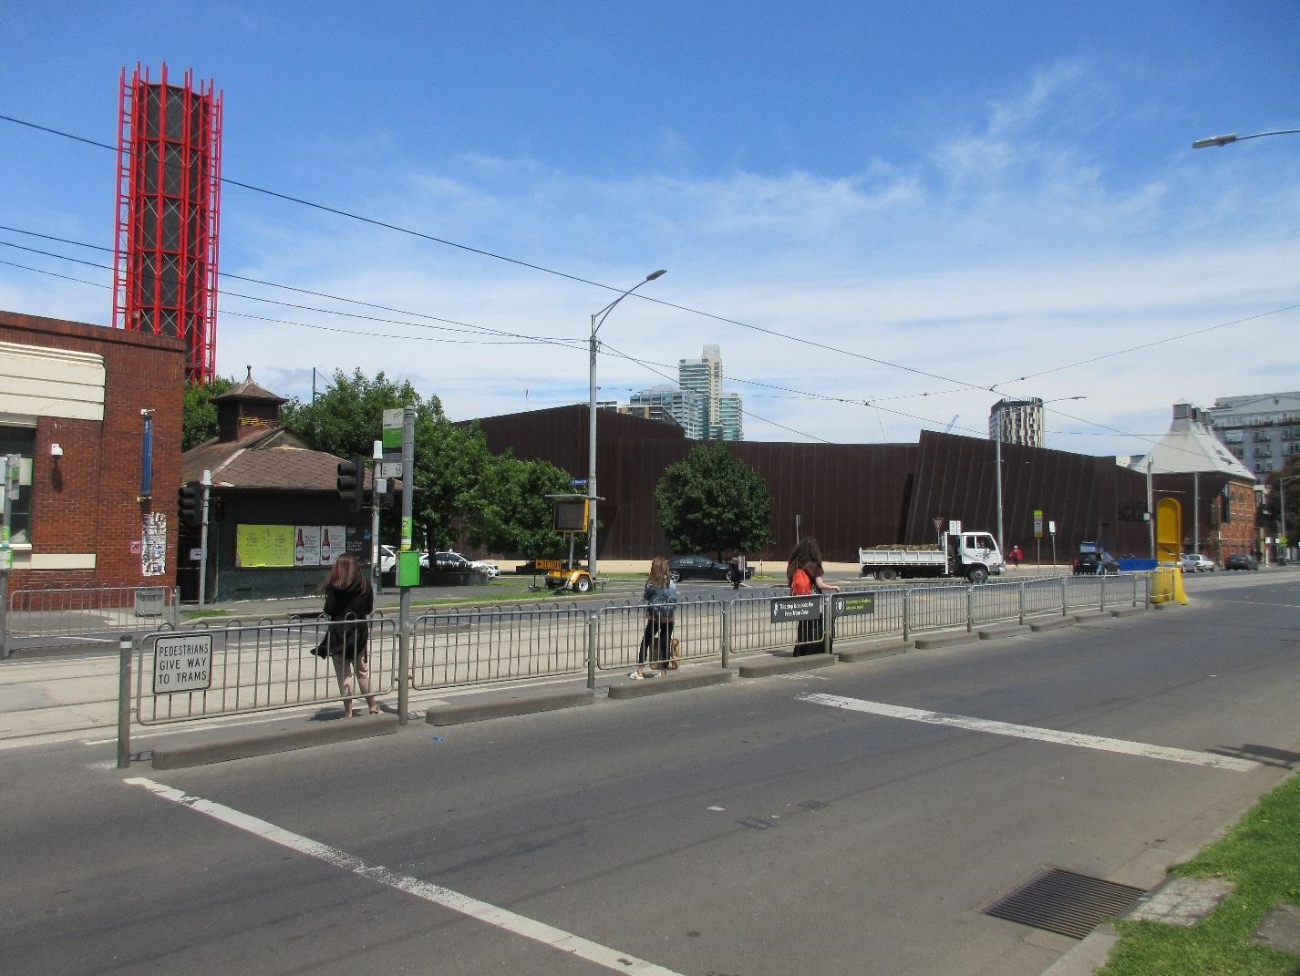
Image description: A photo overlooking a road with a tram stop lined by a metal fence in the centre. Across the road and to the right we can see the dark brown exterior of the Australian Centre for Contemporary Art and the Malthouse next to it in the distance. The sky is blue overhead.

Car drop-off
The best place for quick car drop-off is at the laneway entrance between ACCA (111 Sturt St) and Malthouse Theatre (113 Sturt St). There is a break between parking spaces which will allow a car to safely pull over and let passengers out. There is also a large curb cut at the entrance to this laneway.
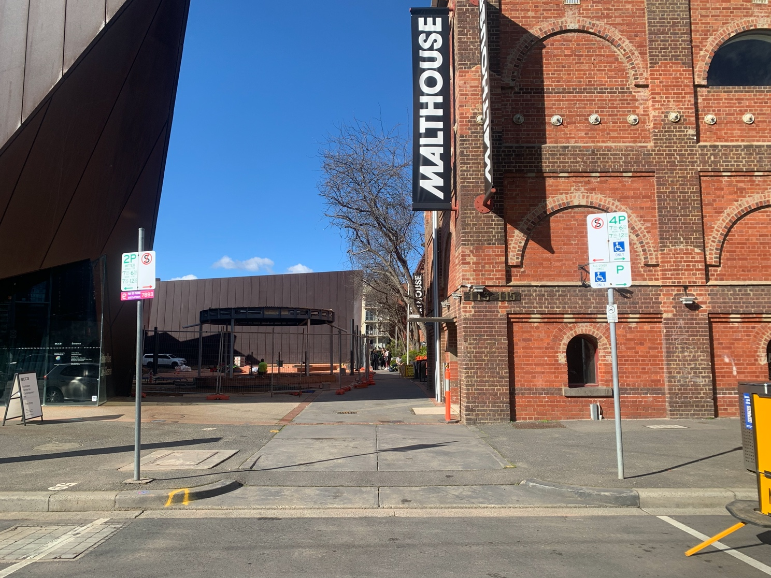
Image description: a photo of the Sturt St entrance to the Malthouse showing the curb cut from the road to the pathway with parking signs on either side. To the right of the path is the red brick corner of the Malthouse building and to the left is a fenced off construction area with a large brown building behind it.

Accessible Taxi drop-off
The best place for wheelchair user drop-off is at the Dodds Street entrance which generally has less traffic and is closer to the DDA compliant entry.
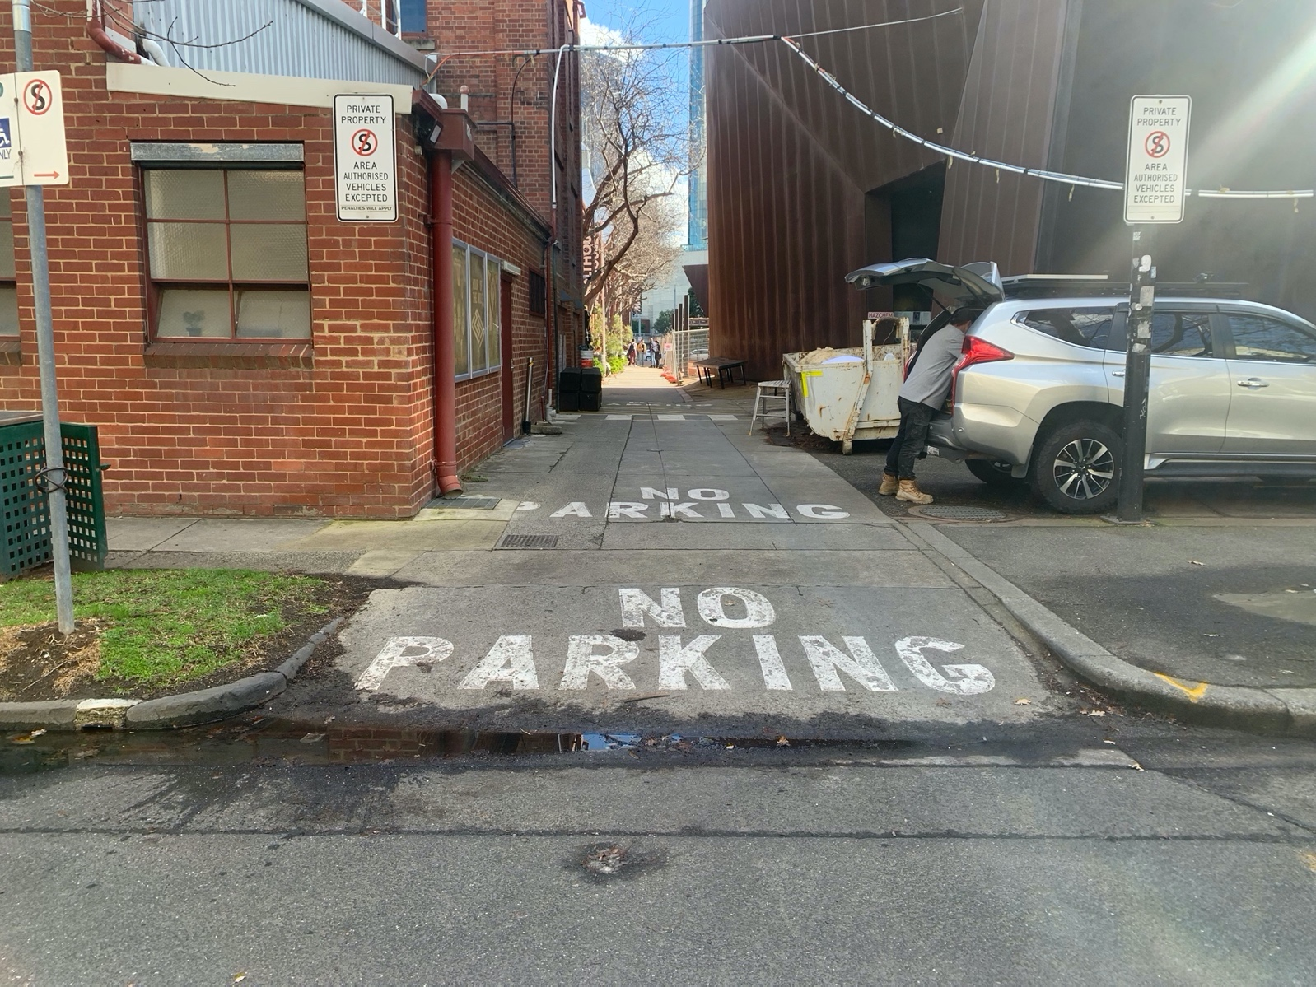
Image description: a photo of the Dodds St pathway entrance showing the curb cut to the road with NO PARKING writing in large white font painted on the path. To the right of the path is a silver station wagon with the corner of a large brown building behind it. To the left is the red brick corner of the rear of the Malthouse.

There is a laneway with a large curb cut between 68 Dodds St and the rear of the Malthouse, with a break between parking spaces, although this may not be big enough for some larger vehicles. If this is the case, a larger break in parking is located approximately 10m towards Grant St.
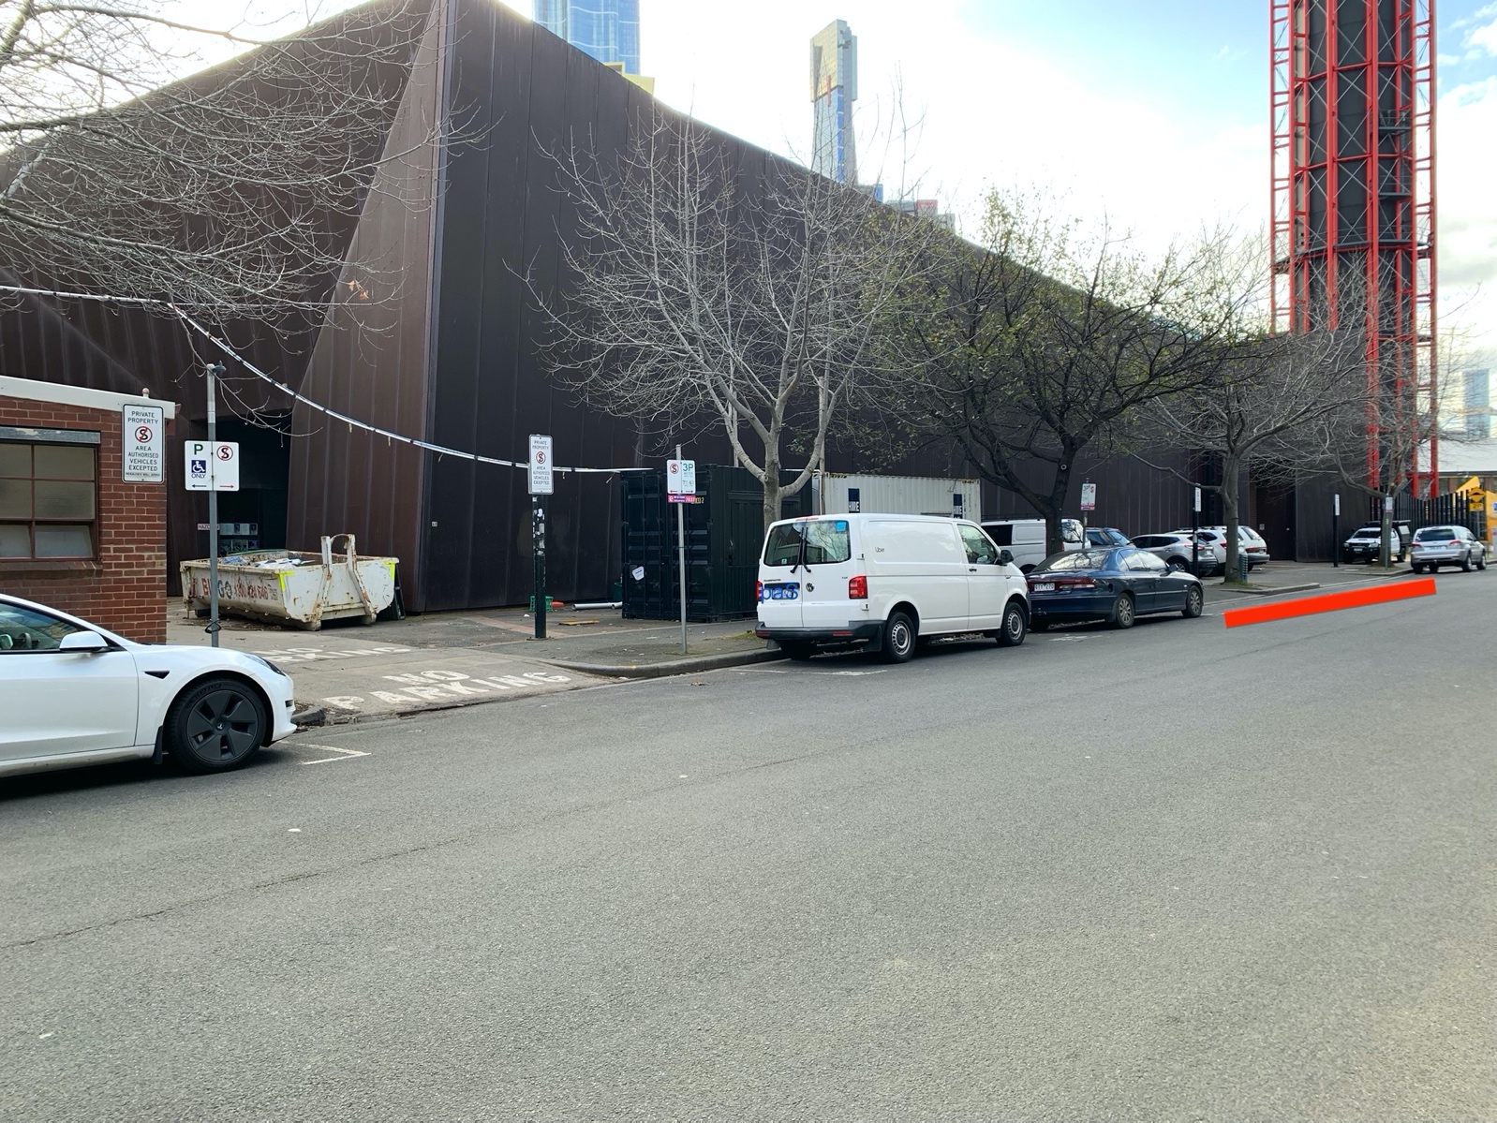
Image description: a photo of Dodds St with a large space between parked cars highlighted with a bold red line. The rear red brick corner of the Malthouse is visible on the left, the pathway entrance from Dodds St in front of it and a large dark brown building opposite.

Parking:
There is limited on-street parking on Grant Street, Sturt Street and Dodds Street which is unmetered after 6:30pm on weekdays, 12pm on Saturdays and all-day Sundays. There are 2 accessible spaces outside The Malthouse on Sturt Street and another two near the Dodds St entrance.

The closest secure carparks are the Arts Centre Melbourne Car Park (4 Sturt Street) and The Australian Ballet Centre Car Park (2 Kavanagh Street).

VENUE ACCESS

Entrances
The Malthouse is a large red brick building which can be accessed via the pathway which runs along the north facing wall of the building between Sturt St and Dodds St. There is a large curb cut from the road to the pathway at either end, and a relatively smooth, concrete passage which runs alongside the building. Please note there are currently construction works being completed opposite the Malthouse which are fenced off along of the edge of this path.
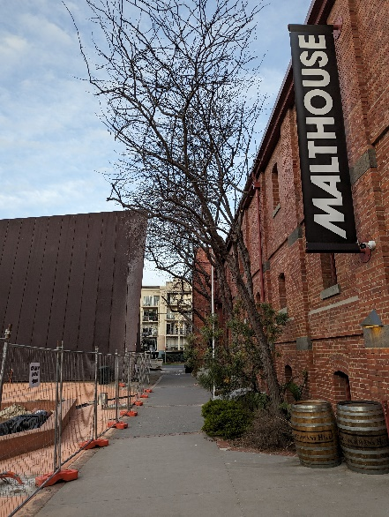
Image description: A photo of the path alongside the Malthouse, taken from the Sturt St end, looking through to Dodds St. There is construction fencing to the left and the red brick facade of the Malthouse to the right. A black sign with bold white text hangs on the side of the building. It reads: MALTHOUSE. There is a small garden and two wine barrels along the edge of the building.

There is also a strip of loose dirt which runs vertically across the path, between the two entrance doors. This strip is approximately 60cm wide.

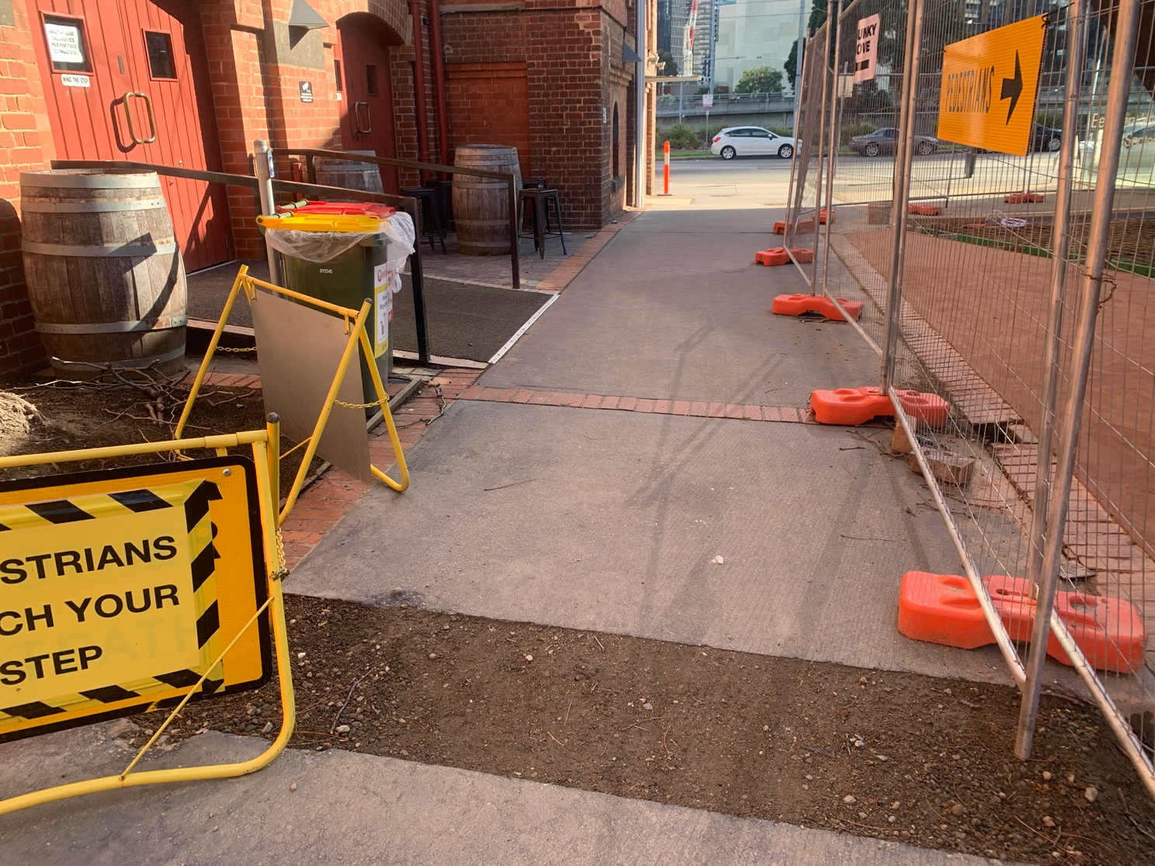
Image description: a photo of the concrete path, with a vertical strip of loose, darker grey/brown earth. To the left of the strip is a yellow construction sign and the red brick wall of the Malthouse. At the end of the path, we can see a road (Sturt St), and to the right is construction fencing.

Sturt St Entrance
The path to this entrance is between ACCA (111 Sturt St) and the Malthouse (113 Sturt St). There are 2 small (21cm x 21cm) metal grills in the centre of this path, at the Sturt St end.
Image description: a photo of the Sturt St entrance to the Malthouse showing the curb cut from the road to the pathway with parking signs on either side. To the right of the path is the red brick corner of the Malthouse building and to the left is a fenced off construction area with a large brown building behind it.

The Sturt St entrance door is located approximately 10 metres along the path and to your right, via a non-slip ramp with handrails either side. Please note that this ramp is not DDA compliant and may be too steep for some mobility aid users. The ramp leads to large wooden, manually operated double doors. One of the 100cm wide doors are usually ajar before performances. Behind these doors are automated sliding glass doors which will open as you approach them. There is a slight lip and a non-slip mat at the doorway entrance.
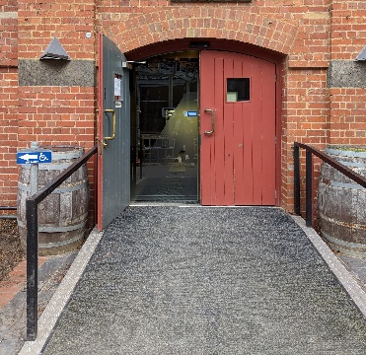
Image description: A grey ramp with black, metal handrails leading to a red brick building with a double door which is open on the left. There is a glass sliding door behind it.

Dodds St / DDA Compliant Entrance
The DDA compliant entrance is via the path between 68 Dodds St, which is a large dark brown building, and the rear of the Malthouse.
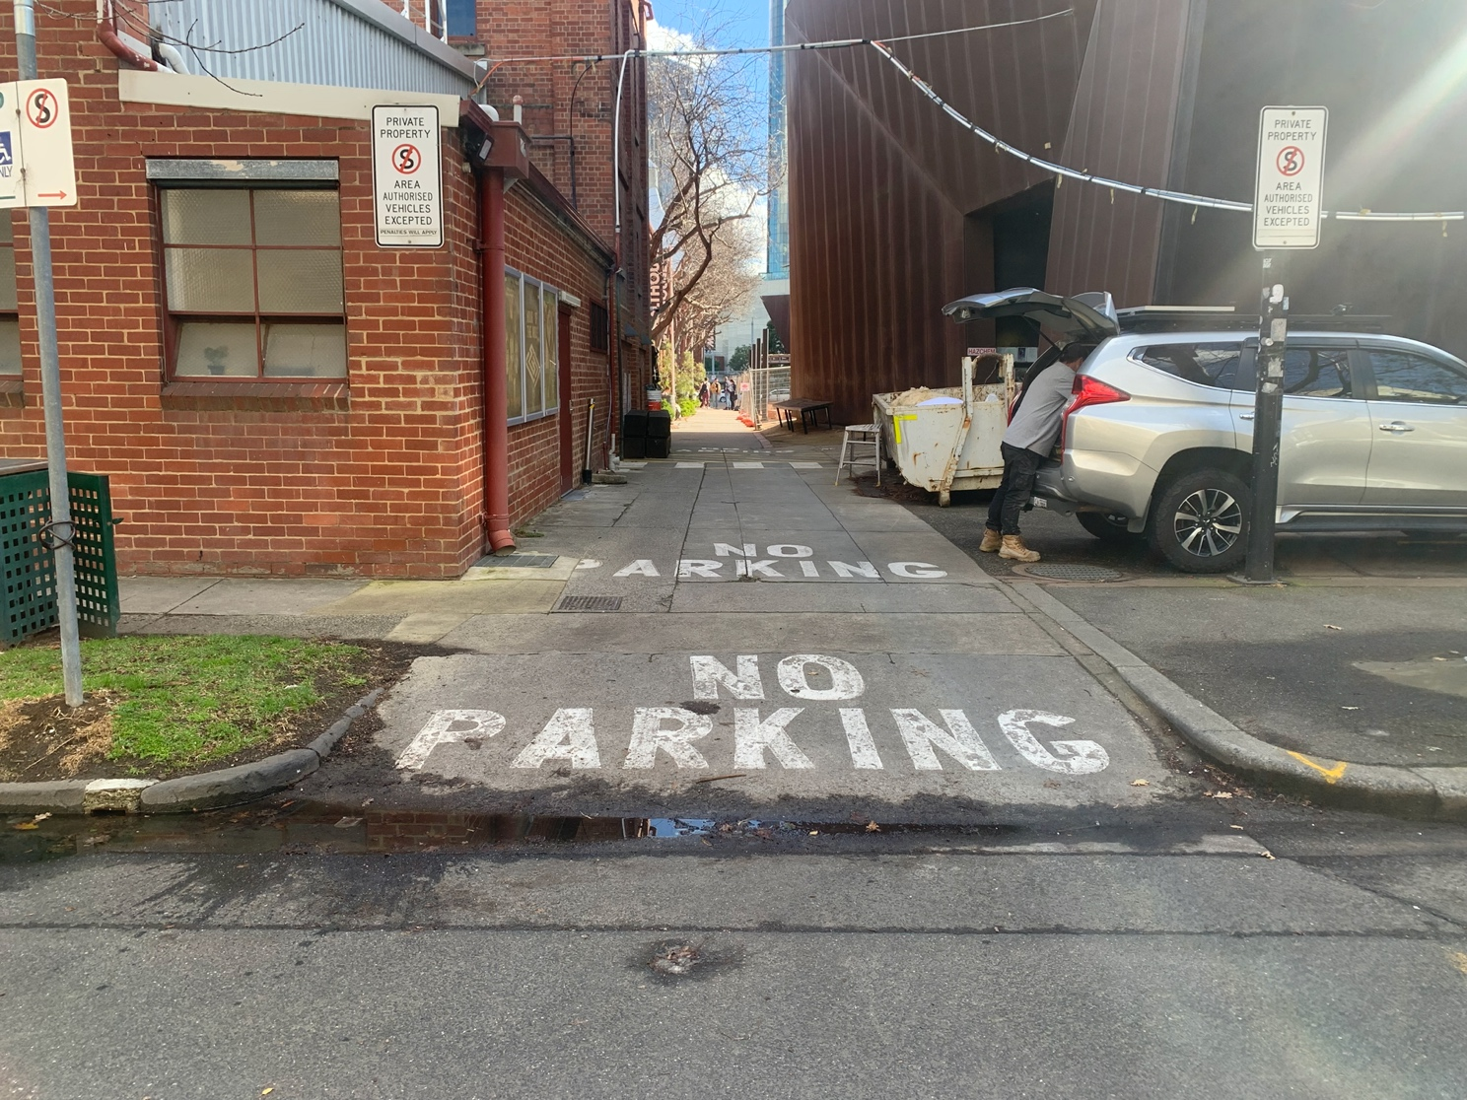
Image description: a photo of the Dodds St pathway entrance showing the curb cut to the road with NO PARKING writing in large white font painted on the path. To the right of the path is a silver station wagon with the corner of a large brown building behind it. To the left is the red brick corner of the rear of the Malthouse.

Two sets of large wooden double doors are located around 100m along the path and to your left. These doors are 100cm wide each and are kept ajar for performances. Behind these doors are automated sliding glass doors which will open as you approach. The interior floor of the malthouse is level with the path at this entrance. There is a very small lip as you pass through the glass doors.
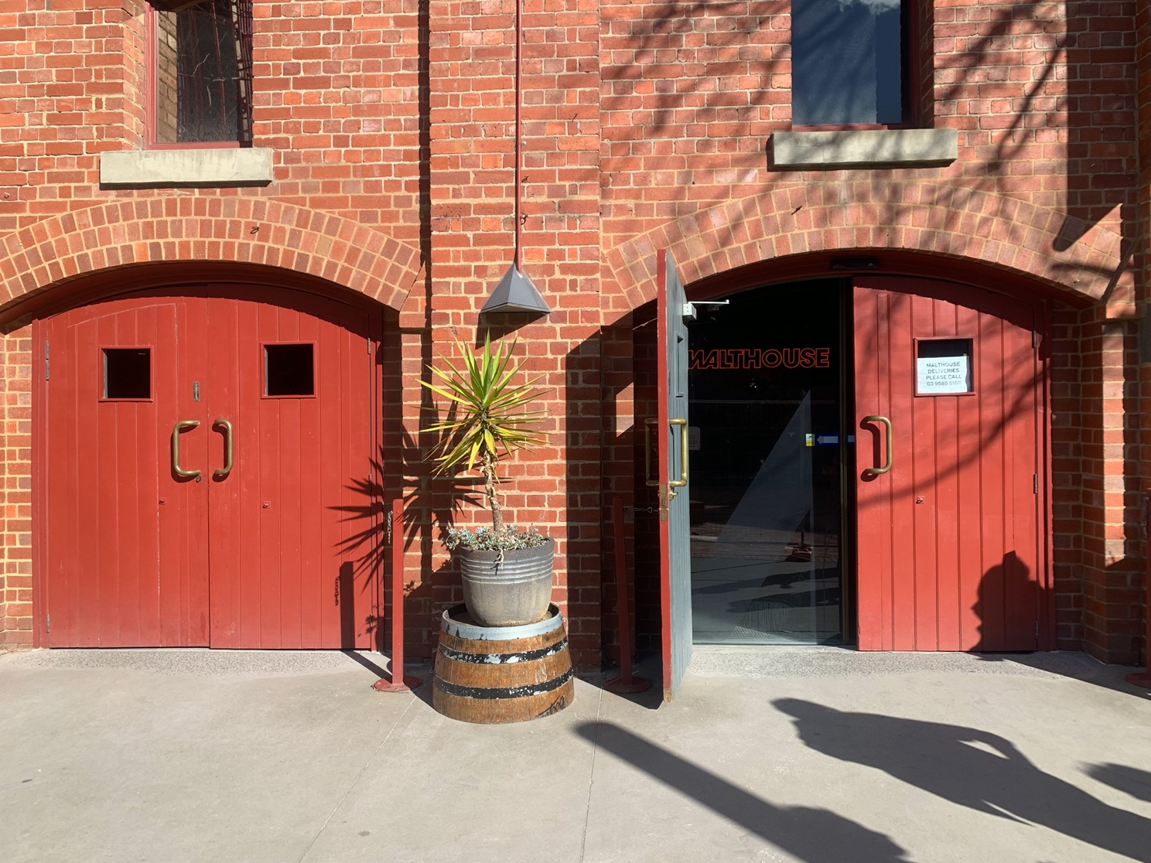

Image description: a photo of the two double doors at the Dodds St entrance. The exterior of the doors is red as is the brick wall which houses them. Smooth grey concrete leads to both sets of doors. In the right image, the left door is ajar, and we can see the glass door behind it. The doors on the left are closed.

Foyer
Both entrances to the Malthouse lead directly into the foyer which is a large open space with polished concrete floors and high ceilings. The foyer tends to be busy and can be quite noisy, before and after shows. It is softly lit from overhead with scattered light boxes, posters and signs around the walls.
At the Dodds St end of the foyer is the Box Office and the Beckett Theatre to its right. There is a staircase opposite the Dodds St entrance with two small couches to its left and the door to the Sumner Theatre to it’s right. This staircase leads to the Mezzanine level and main bathrooms.
At the Sturt St end of the foyer is Koyzina Café and dining area, and a large communal table which is to the right of the door as you enter.
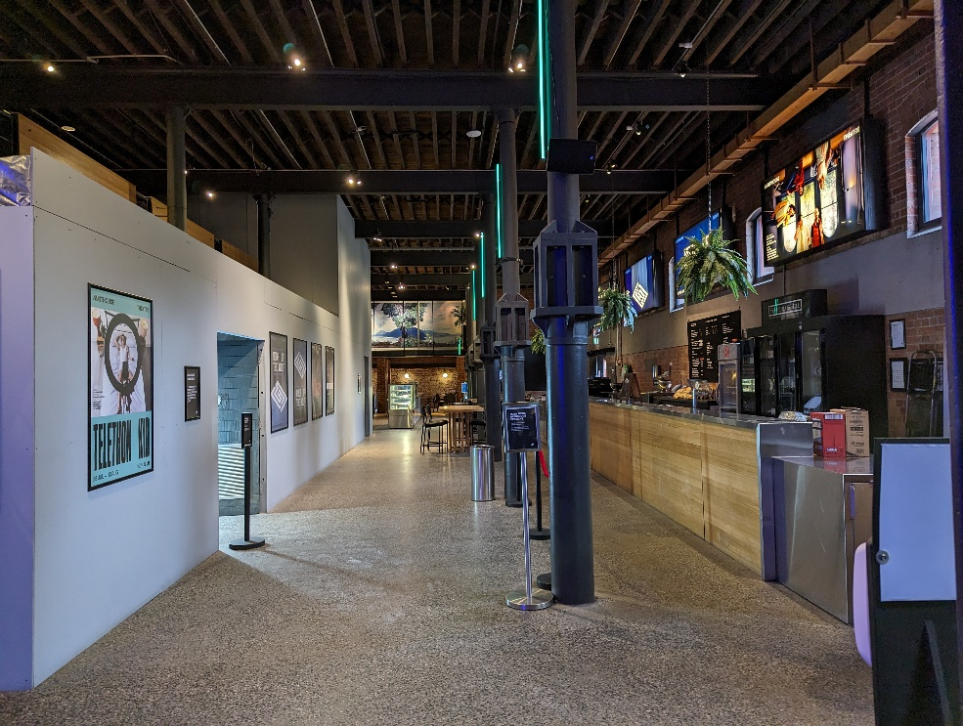
Between the Sturt St and Dodds St entrances to the foyer is the Malthouse Bar, and the accessible bathroom which is tucked into the wall opposite.

Image description: A photo of the foyer taken from the Dodd’s St end. Along the right wall is the stainless-steel topped bar with fridges and light box posters behind it. In the centre is a row of metal pillars with tables and chairs behind them and to the left is a light grey wall with posters and blue door opening midway down it.

Box Office
The Box Office is directly to your left once inside the Dodds St entrance to the Malthouse. There is a vertical light box suspended above which reads “Box Office” sideways. The Box Office desk is made from painted black wood and is 106cm high. Staff are happy come around to the front of the desk to assist you if needed.

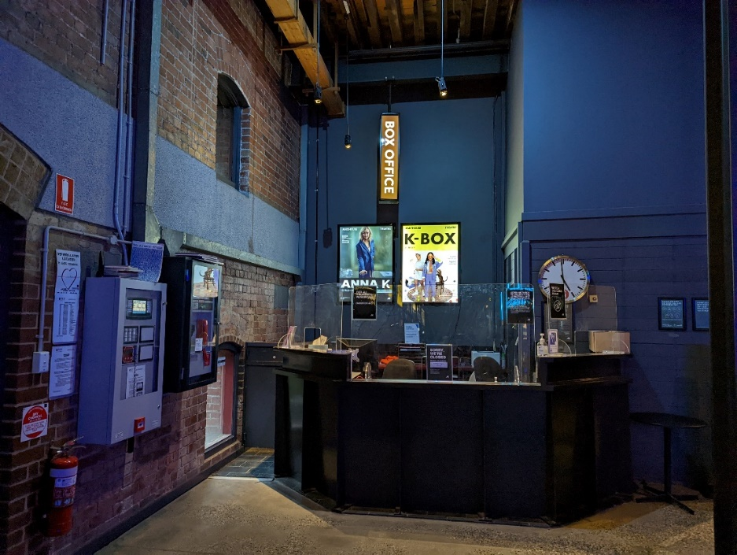
Pre-booked tickets will be held under your surname and can be collected from here before the performance. You may be asked to show the Box Office staff your concession and/or companion card if you have used these to book tickets.

Image description: a photo of the Box Office in the corner of the foyer, with a black façade and Perspex shield above the desk. There are light box posters and the vertically suspended box office sign above. The walls behind the desk are grey and the wall to its left is red brick.

Bar
The Malthouse Bar runs along the wall between the Sturt St and Dodds St entrance doors. The bar itself is made of stainless steel with lowered, 109cm high sections at either end, while the central service area is 116cm high. The bar sells a variety of alcoholic and non-alcoholic drinks, olives and packets of chips. Please ask the bar staff if you would prefer your drink served in a plastic tumbler or with a straw.
There is a self-serve water station on a wooden bench, 103cm high, at the Dodds St end of the bar. This bench adjoins a lower, 80cm countertop with padded, 45cm high stools.
In front of the bar are a row of 90cm high tables, with 60cm high backed bar stools. Dotted between these tables are a row of 7 structural steel pillars which extend to the ceiling. The pillars and tables are around 150cm from the bar.

Koyzina Café
Directly opposite the Sturt St entrance door is Koyzina Café which serves a limited menu of Greek foods and coffee. The Café is open until 9pm each night and accepts payment by card only. Please order at the counter which is 90cm high.
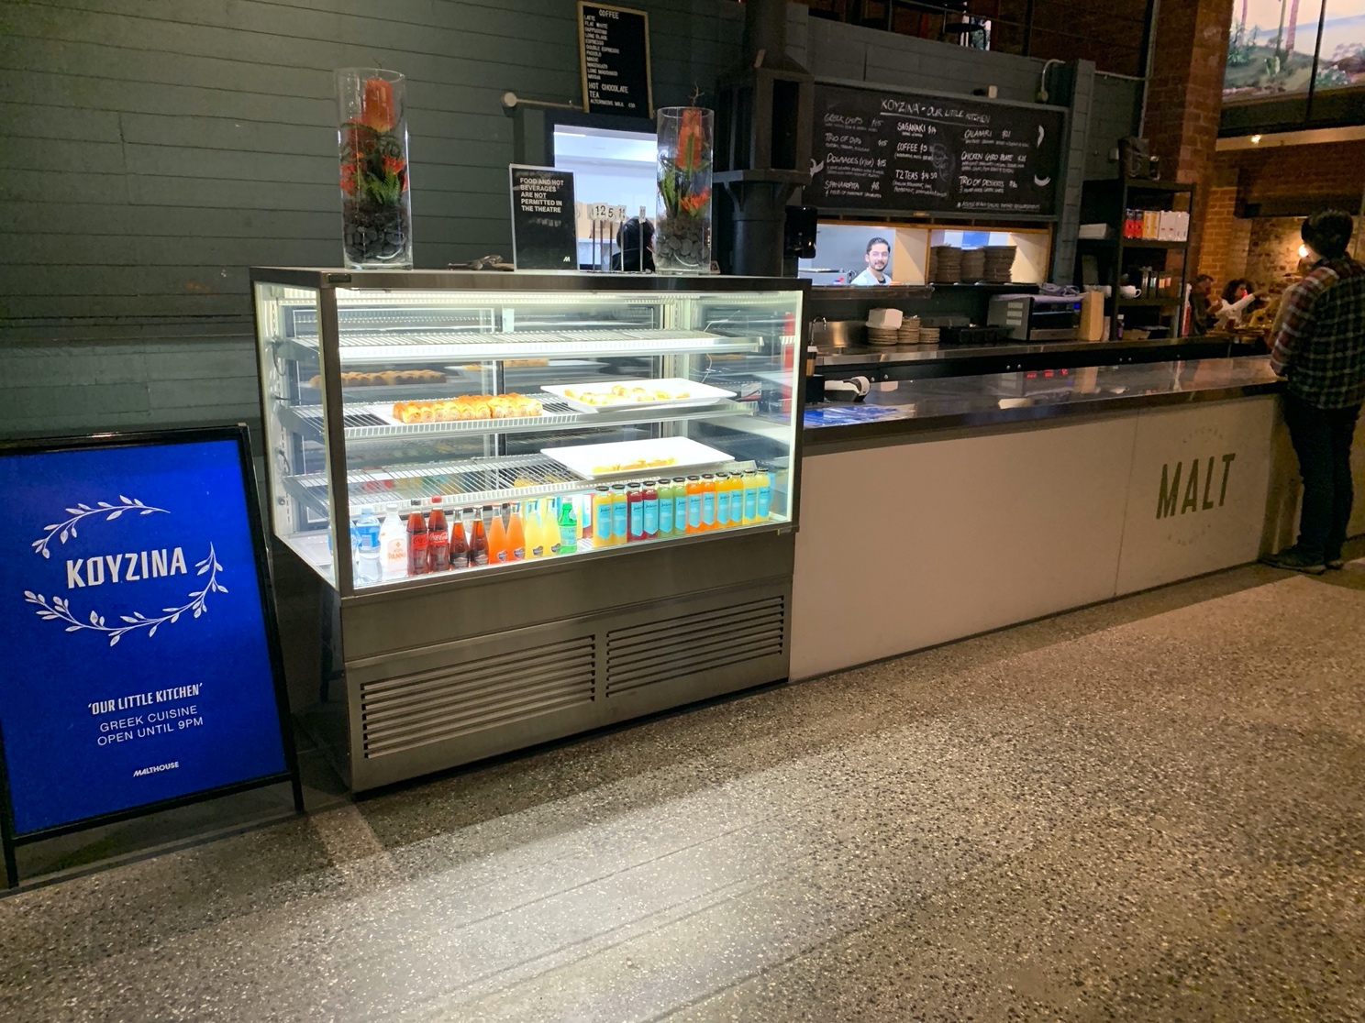
Image description: a photo taken of Koyzina Café, inside the foyer. There is an illuminated glass cabinet with plates of food to the left and a stainless-steel countertop with a window through to the kitchen and a blackboard mounted above it to the right.

Bathrooms

Accessible bathroom
The accessible bathroom at the Malthouse is currently undergoing an upgrade. There is a temporary DDA compliant bathroom in the centre of the foyer wall opposite the bar. This bathroom is for all genders and has grab rails to the left and rear right of the toilet. The toilet door is manually operated and has a turning lock mechanism.
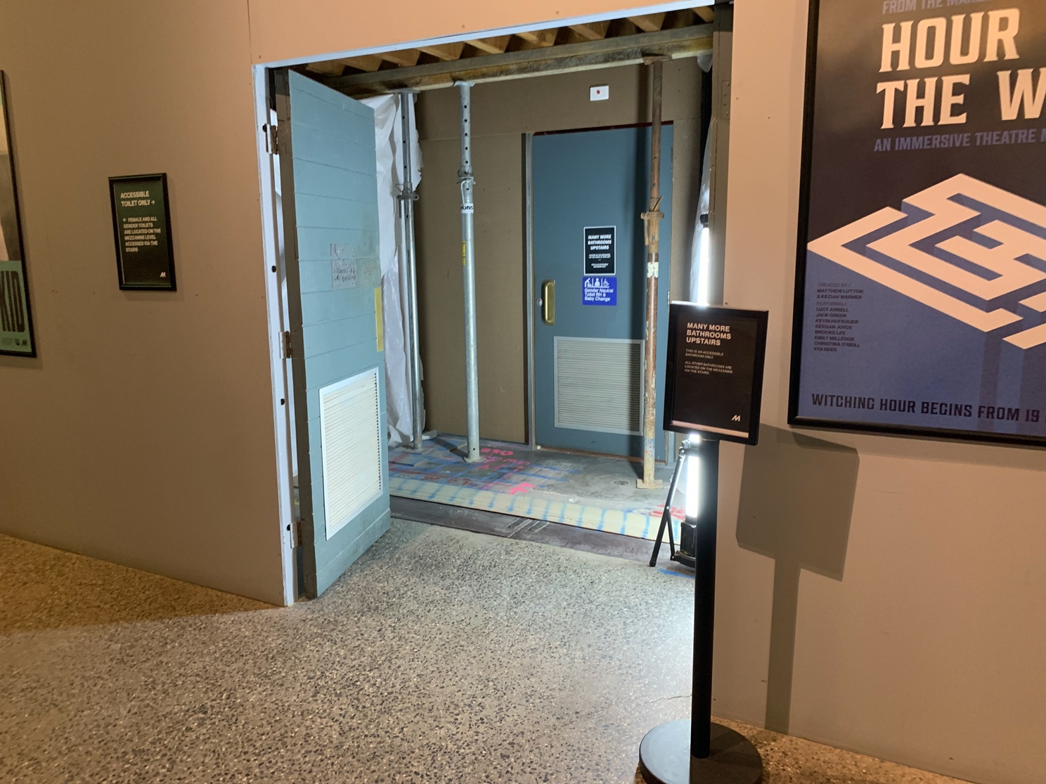
Image description: a photo of the alcove entrance and door to the accessible bathroom. The alcove is housed in the light grey walls of the foyer, and the door to the bathroom is pale blue. There are two steel poles on either side of the door, supporting a low ceiling.

Thank you for your patience while the facilities are improved.

Ambulant, female and all gendered bathrooms
There are female, all gendered and ambulant toilets on the mezzanine level which can be accessed via the staircase directly opposite the Dodds St entrance to the foyer. There are 16 steps to this level with handrails either side. The bathrooms are approximately 6 metres from the mezzanine landing and off to the left.

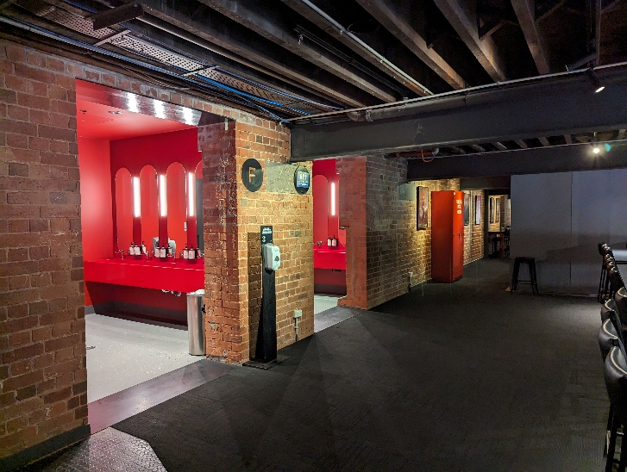
The walls and cubicles in both the female and all gendered bathrooms are painted bright red with vertical lights lining either side of the mirrors at the sinks.
Image description: a photo of the entrance to the bathrooms taken from the mezzanine. The female designated bathrooms are to the left of the image and all gendered to the right. The walls and ceiling of the entrance are painted bright red. There is grey carpet on the floor of the mezzanine and blue linoleum on the floor of the bathrooms.

The Beckett Theatre
The doors to the theatre are to the right of the box office at the Dodds St end of the foyer. Front of House Staff will open the doors to the theatre approximately 15mins before the show begins. There will be a PA announcement in the foyer when the theatre is open.
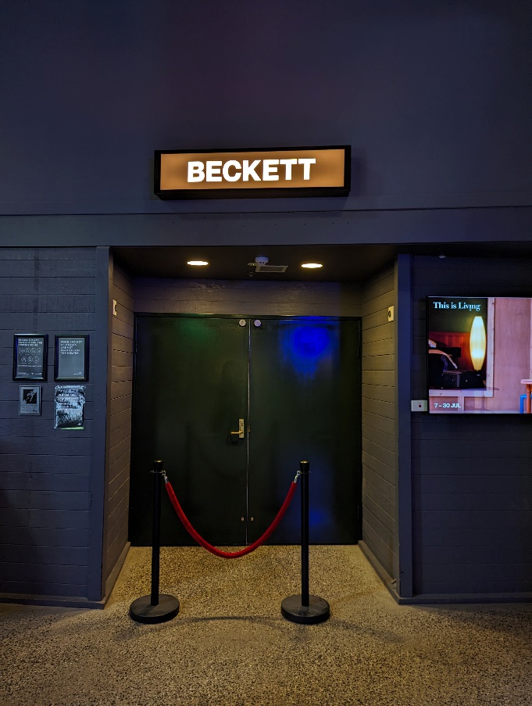
Image description: a photo of the dark green double doors to the Beckett theatre, closed. There is a red velvet rope sectioning off the entrance and a light box overhead which reads, BECKETT. The door is set back from the dark grey walls surrounding it, creating an alcove.

Front of House Staff will scan your ticket at the theatre doors and direct you to your seat. You will enter from behind the seating bank and will need to follow the walls to either side of it to get around to the front. The narrowest part of this passage is 80cm wide. There are metal grate strips on the floor which run alongside the walls of The Beckett. These grates extend 35cm from the walls and may be hazardous for people wearing high heels.

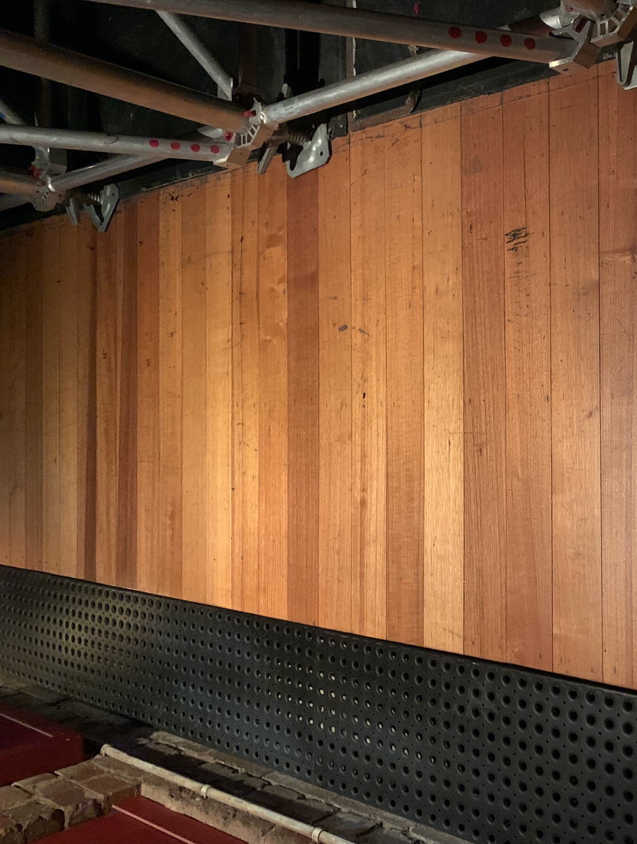
Image description: A photo of the floor as it runs between the seating bank and the wall in The Beckett. Along the left edge of the floor is a strip of black metal grating with small circular cut outs. There are polished floor boards between the grate and the edge of the metal frame of the seating bank to the right.

The Beckett is a black box theatre space with raked seating. The theatre can seat 198 people. There are rows of seating labelled A to M and each seat has a number.
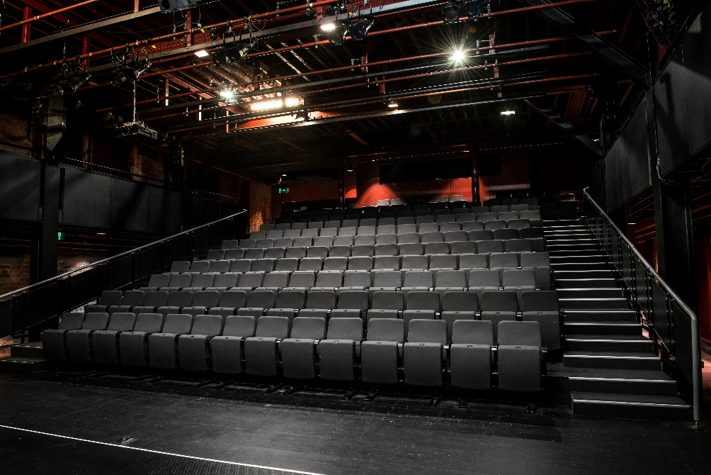

Image description: a photo of the black seating bank inside the Beckett Theatre, taken from the floor. Many rows of dark grey seats extend back and upwards. There are black steps extending up the right side of the seats with white tap on the edges and a silver handrail to the right.

Quiet space
A designated quiet space with bean bags, fidgets, headphones, sound & light control and drinking water is is available on level 2 of the Malthouse in the Playbox. This can be accessed via the stairs to the left of the Merlyn Theatre door or by lift with the assistance of a Front of House Staff member. Please see a Front of House Staff member if you would like to use this space or simply follow the “Quiet space” signs up to the top of the stairs and turn right, then head to the end of the corridor. The Quiet space is through the door to your right.
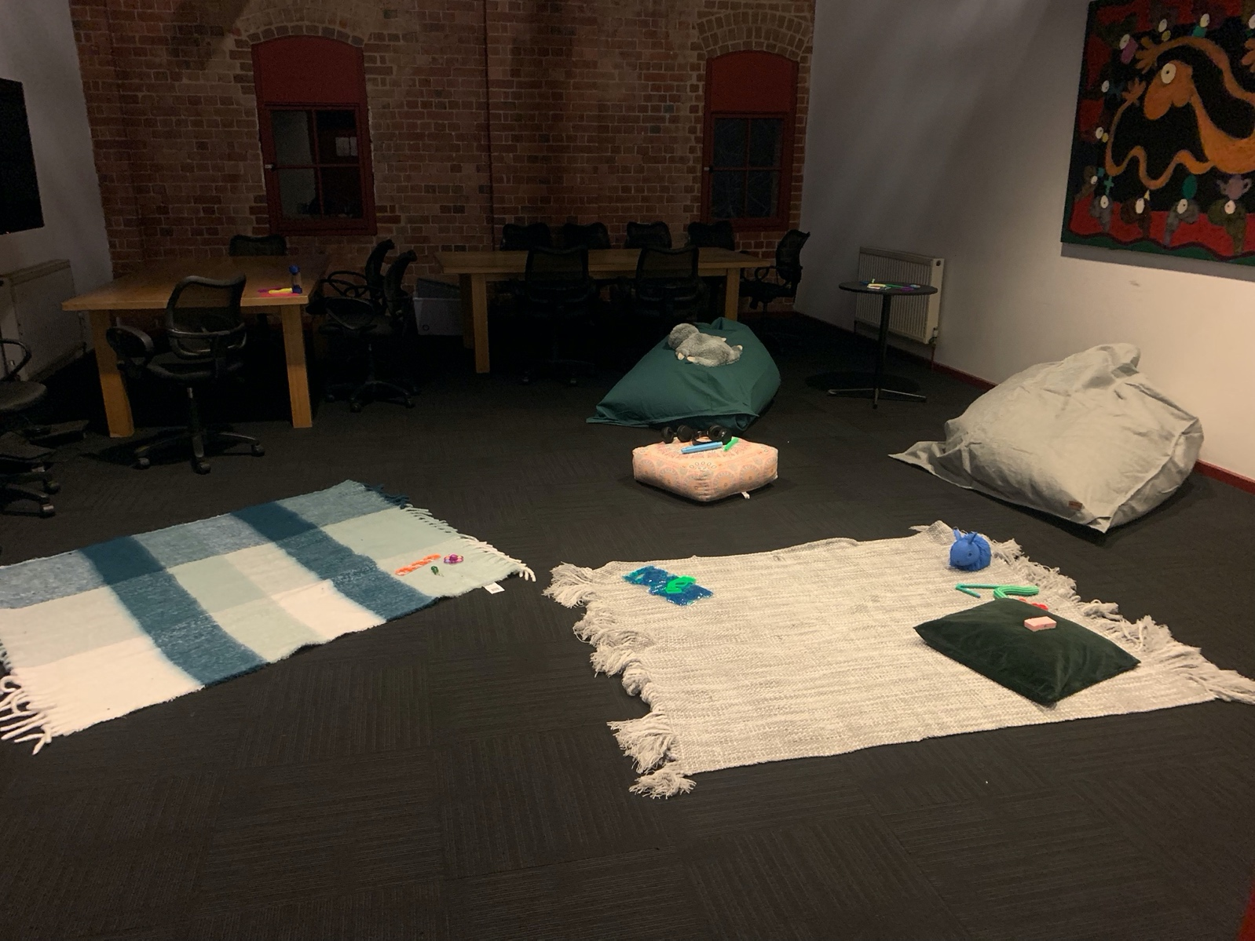
Image description: a photo of the Quiet space with grey carpet and two rugs on the floor in light grey and blue. There are cushions and fidget toys on the rugs and bean bags and chairs around their edges. There is a large, darkly coloured Leunig painting hanging from the wall to the right and a brick wall at the end of the room.

INFORMATION ABOUT THE SHOW

Sensory information

Sound design
This show involves the use of dynamic, bass heavy music and sound effects including low rumbling drone sounds, short high-pitched beeping, distorted and abrasive electronic music, music with brass instruments, synthesizers and electronic string sounds. The sound can be loud at times and can vibrate the seating bank slightly. Occasionally music or sound begins abruptly and at high volume.

Lighting design
Lighting states occasionally switch rapidly in this show but for the most part, states and colours change slowly. Whilst no stage lights are angled directly towards the audience, light sensitive people are advised to book tickets from Row F backwards. There is one point in the play which features an overhead fluorescent light tube which flickers for a period of approximately 5 seconds. This light is located on the left-hand side of the stage from the audience.
At one point, the light from two follow spots move across closed curtains for approximately 5 seconds before landing on a character.
There is a large, glowing table stand in one scene which is covered in white fabric and slowly changes colour.

Dialogue
Dialogue is often spoken rapidly between characters, at times with their faces away from the audience.

Projections
There is a large projection screen which drops slowly in and out from above on the stage. On this screen plays video with medical imagery, sick people, syringes, hospitals and medical equipment. There is also a stark, white power-point presentation featuring medical photography and moving numbers.

Reflective objects
Some highly reflective objects move on stage including metallic jewellery, glassware and silver catering equipment.

Busy patterns on costumes
One character’s costume features a brightly coloured orange, pink and blue leopard print all over.

Content warnings and notes
PLEASE NOTE THE FOLLOWING CONTAIN SPOILERS

Frequent coarse and derogatory language
The following coarse language is used frequently throughout the show:
· Fuck
· Fucking
The following derogatory terms and coarse language is used on occasion throughout the show:
· Fugly
· Faggot
· Cocky bastard
· Bitch
· Genetic alien
· Inbred

Sexual intimacy between consenting adults and partial nudity
There are multiple moments of explicit sexual intimacy between the characters of Sam and Doc.
These simulations include but are not limited to: kissing, caressing, peer masturbation and anal sex.
There is no full nudity on stage.
There is a scene where the ghost of Sam kisses Doc. During the kiss, Sam’s body becomes a corpse
again.

Frequent discussion of disability, chronic pain and chronic illness
The story is set at a fictional conference for rare diseases. The audience meets the character of Sam,
who has compound heterozygous titin myopathy type 2a. The audience also follows the story of Evie
who has Rheumatoid Arthritis and ADHD. Consequently, there is frequent discussion surrounding
both Sam and Evie’s specific disabilities, as well as disability in general – including but not limited to
treatments and medical trials, the medicalization and pathologizing of disabled people,
infantilization and paternalism within the medical system, the desexualizing of disabled bodies, and
the monetization and exploitation of disability and chronic illness in the medical industry.

Frequent depictions of ableism
There are frequent depictions of ableism within the text. This include but are not limited to:
- Disabled people being reduced to their medical diagnoses
- Non-disabled characters telling disabled characters how they should feel, what decisions to
make and what they should do with their bodies.
- Denial of personal agency, particularly as it relates to disabled women
- Infantilization and paternalism within the medical system and broader society
- The desexualizing of disabled people
- Monetization and exploitation of disability and chronic illness.
- Abuse of power dynamics by non-disabled characters in positions of authority.
- Pity and the victimization of disabled people
- Charity and non-disabled heroism
- Multiple discussions about medical conditions being named after the non-disabled doctors
who researched them, instead of the disabled people who experience them.
- Devaluation of the lived experience of disabled people

Frequent depictions of medial and hospital imagery, devices and treatments
Including but not limited to:
- Syringes
- Stock video of healthy children depicting sick children
- Microscopic images of internal tissue
- Pills and other medications

Discussion of grooming and medical consent
After having sexual relations, the characters of Sam and Doc have a detailed discussion about
whether Doc groomed Sam, and the ethics, blurred lines and nuances of medical consent.

References to death, dying and mortality
Throughout the show, there are multiple references to death, dying and mortality.
In a light-hearted manner, the character of Sam references multiple occurrences of nearly dying as a
child.
There multiple conversations surrounding mortality, and what it means to truly live.

References to sexual assault
There is a plotline in the play where Doc is investigating a series of sexual assaults committed by a
doctor who attempted to pass them as medical examinations, specifically an examination of the
lymph nodes, to his patients. The fictional medical corporation in the piece, Geneuris, covers the
assaults up. The perpetrator is not a character we see on stage and no sexual assault is depicted on
stage.

Depictions of alcohol consumption
There are multiple occurrences where the characters depict the consumption of alcohol and being
intoxicated.

Depiction of a medical procedure
At the end of the play, the character of Doc depicts undertaking a tissue extraction procedure on a
corpse.

References to drug consumption
There are multiple mentions of the consumption of weed but no character takes any onstage.

