Accessibility and
Pre-Show information
seven methods of killing kylie jenner

18-29 JANUARY 2023
BECKETT THEATRE

This document contains relevant accessibility information and show information to help
prepare you for your visit to our venue. This includes information such as lighting states,
content or trigger warnings, running times access and the venue.

Please note that this document will include key show information and plot points.

THE MALTHOUSE113 STURT STREET SOUTHBANK VIC 3006
GENERAL INFORMATION / PERFORMANCE STYLE

seven methods of killing kylie jenner
Forbes Magazine claims Kylie Jenner’s a 'self-made billionaire' and Cleo isn’t having a bar of it. She’s got a lot to say and on the internet, actions don’t always speak louder than words…

'Look it’s two tweets that helped me vent my frustrations. It’s really not that deep…'

As URL beef brings up IRL tensions, Cleo and Kara have more issues than getting #blocked will solve. If Black Twitter hasn’t snatched your edges yet, these two bawss-babes surely will.

Written by award-winning British playwright Jasmine Lee-Jones and starring Iolanthe and Chika Ikogwe (Netflix's Heartbreak High), seven methods of killing kylie jenner is a deep dive into the murky waters of colourism and the commodification of Black women.

Dates: 18-29 January 2023

Captioned Performance: Thursday 27 January 2023, 6.30pm

About the show
seven methods of killing kylie jenner is a two (2) person show which takes place on stage on a
slightly raised platform. Throughout the show, a twitter feed is displayed on a box above the
stage.

Themes include - feminism, racism, cancel culture, cyber bullying, queer identity.

Running time
90 minutes (no interval)

Content warnings
Descriptions of Racial Violence.
Substantial coarse and racial language.
References to and Graphic Descriptions of Rape and Sexual Assault.
Haze and strobing.

Allergens
At one point towards the end of the play, the two performers smoke a joint. This is a prop-herbal
cigarette.

Lighting and Sound
- The performers will be amplified by microphone at a natural level.
- The lighting will remain at a bright neutral state throughout the performance.
- The house lights will be dimmed throughout the performance.
- There is the use of strobe lighting and haze throughout the performance.

About the show
- Cleo and Kara are best friends living in London.
- At the start of the play Forbes Magazine has just announced Kylie Jenner as the world’s youngest self-made billionaire.
- The story follows the cyber bullying and racism Cleo faces after she frustratingly tweets about the ways she would kill Kylie Jenner.
- The story also follows the relationship between Cleo and Kara and their different experiences of being black women in the world; Cleo is a darker skinned woman. Kara is lighter skinned.
- Later, the two women get into an argument after an old homophobic tweet from Cleo re-surfaces, which makes Kara question Cleo’s acceptance of her as a lesbian.
- The show looks at the trend of “blackfishing” - where non-black (women mainly) adopt traditionally black features such as hair and makeup for profit (example; Kylie jenner).
- The show also looks at the issues surrounding black men and a dating preference for white women.

The Actors

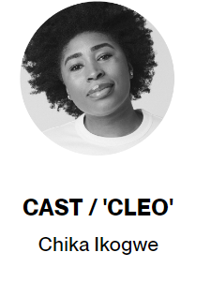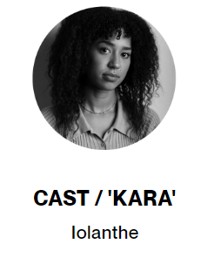

Venue: Beckett Theatre, Malthouse Theatre, 113 Sturt Street, Southbank VIC 3006

Company Website: https://www.malthousetheatre.com.au/

Malthouse Theatre Access Webpage: https://www.malthousetheatre.com.au/your-visit/access/

Seven methods of killing kylie jenner Event Page: https://www.malthousetheatre.com.au/tickets/malthouse-theatre/seven-methods-of-killing-kylie-jenner/

DURATION / Approx. 90 minutes (no interval)

HOW TO BOOK / CONTACT US

Information about The Malthouse venue and seven methods of killing kylie jenner can be found on Malthouse Theatre’s website www.malthousetheatre.com.au

You can book tickets on the website or by calling the Box Office on (03) 9685 5111.

If you have any questions about information in this document, you can contact Laura Hale by emailing lhale@malthousetheatre.com.au or calling (03) 9685 5148

We have reserved an allocation of tickets for each performance which are available for those who face social barriers to attending theatre, especially those who identify as Aboriginal and/or Torres Strait Islander, Black and/or People of Colour, culturally and/or linguistically diverse, d/Deaf, hard of hearing, disabled, neurodivergent and/or chronically ill, or experiencing economic hardship.

To access these tickets, please contact Amarachi Okorom aokorom@malthousetheatre.com.au

Live Captioned - There will be one (1) Live Captioned performance on Friday 27 January 2023,
6.30pm. Captions will be delivered via an app on your smartphone. Further information about the app will be available on the night and Malthouse Theatre has free wifi available onsite.

If you would like to download the app (GoTheatrical Captioning) prior to attending, please click here.

We are committed to continual improvement and learning and welcome your feedback.

HOW TO GET TO THE MALTHOUSE

The Malthouse is located at 113 Sturt Street in Southbank. You can get here by tram, train, bike or car.

Tram: The closest tram stop is Stop 18 – Grant Street/Sturt Street (Route 1). You can also get to the venue from St Kilda Road. Get off at Stop 17 – Grant Street, Police Memorial/St Kilda Road. From this stop, it is a 6-minute walk to the venue via Grant Street.
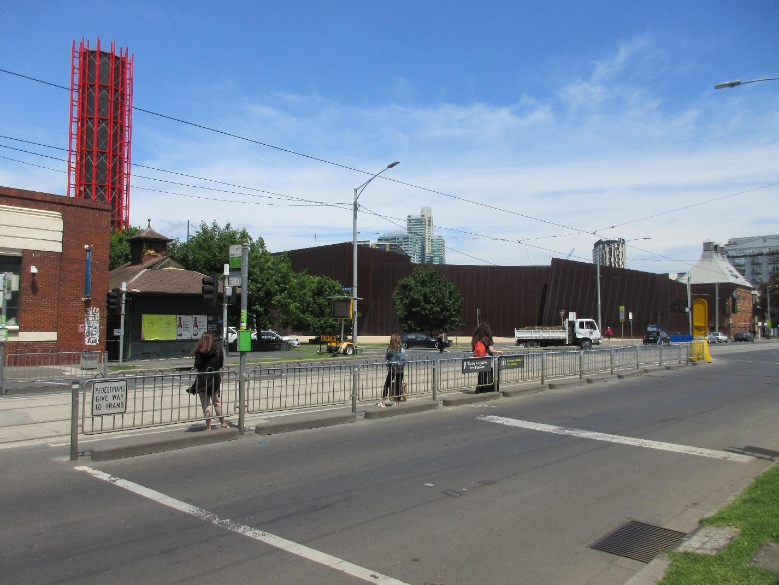
Pictured above: The view of Stop 18 with Malthouse and ACCA in the distance

Train: Flinders Street station is approximately 15-minute walk away.

Bike: There are bike racks and a Melbourne Bike Share station outside The Malthouse.

Car: There is limited on-street parking on Grant Street, Sturt Street and Dodds Street. There are 2 disabled spaces outside The Malthouse entrance on Sturt Street.

The closest secure carparks are:
- Arts Centre Melbourne Car Park (enter from Sturt Street), 850m / 10 min walk
- The Australian Ballet Centre Car Park (2 Kavanagh Street), 600m / 8 min walk

VENUE IMAGES
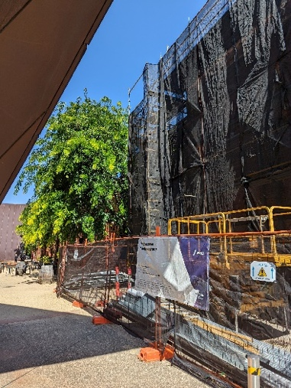
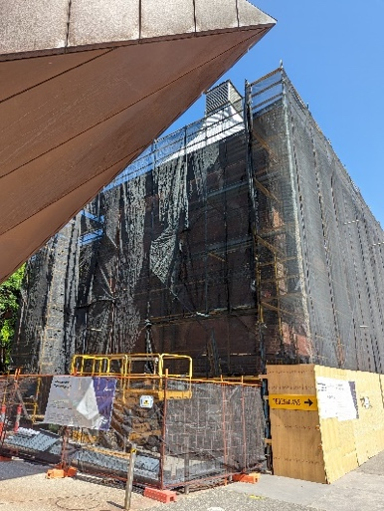
Pictured below: Entrance from Sturt Street side
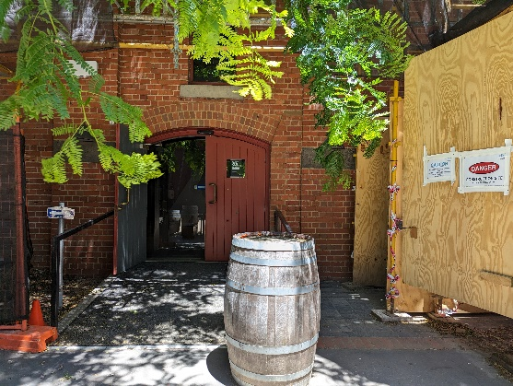

Pictured below: Entrance from Dodds Street side (wheelchair access)
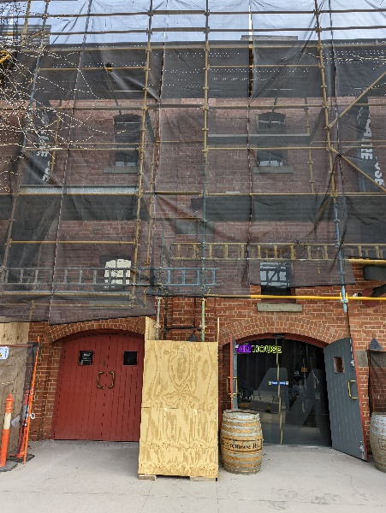
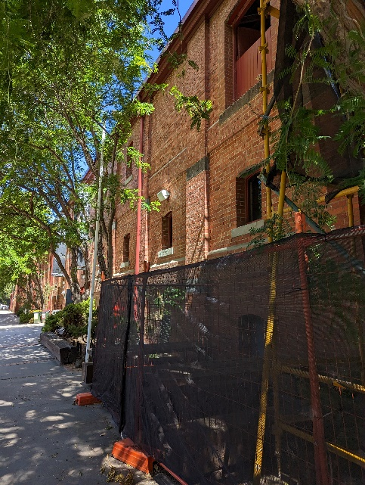

Pictured below: Sanitiser station in the Foyer
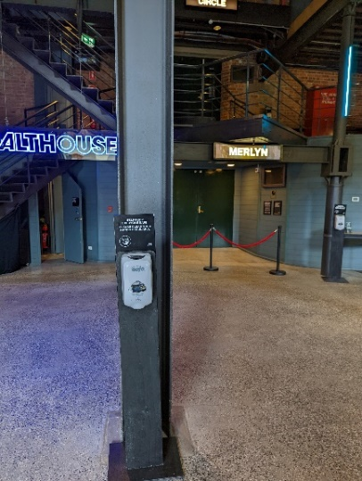

Pictured below: Bar and seating in Foyer
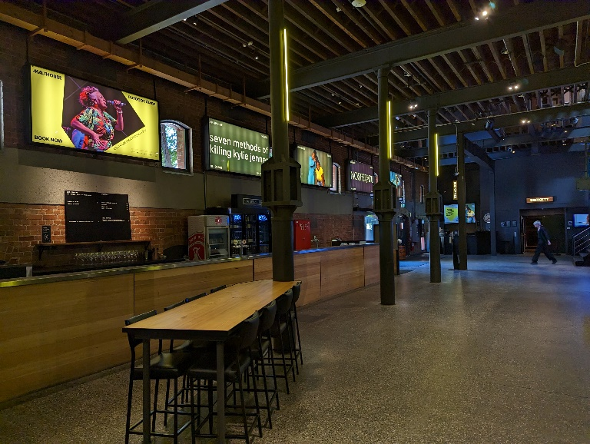

Pictured below: Box Office in the Foyer
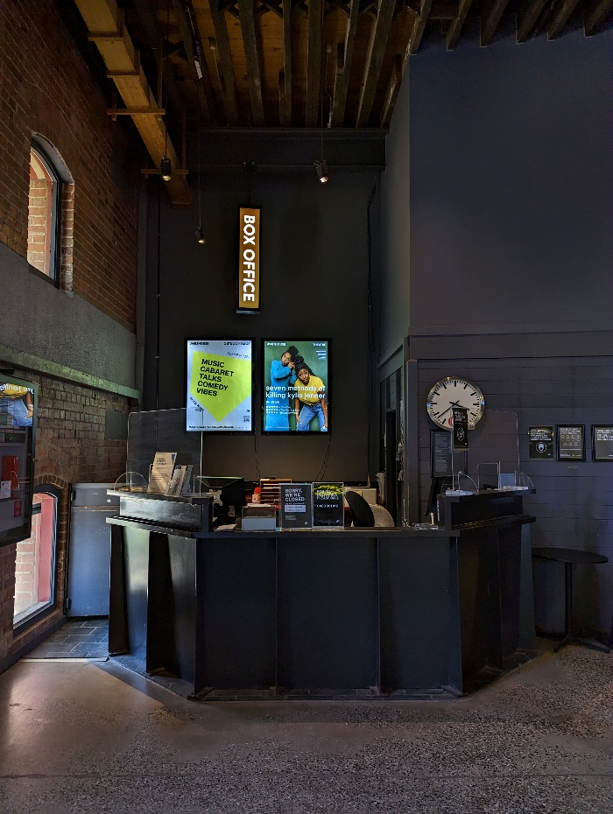

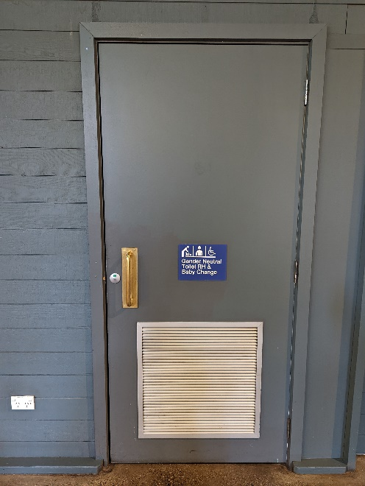
Bathrooms in Foyer
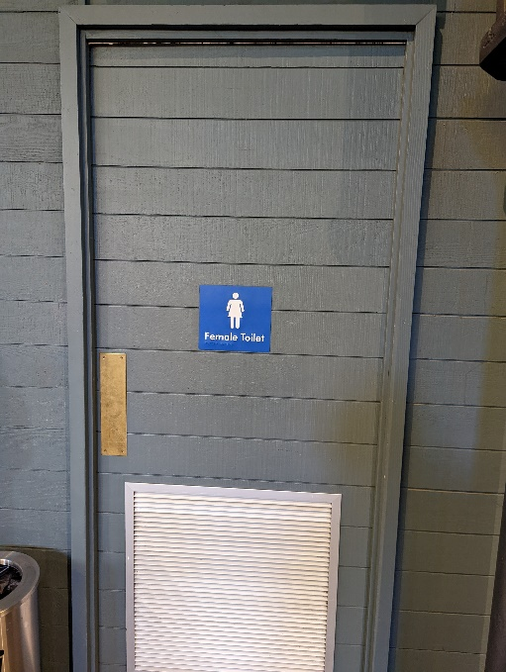
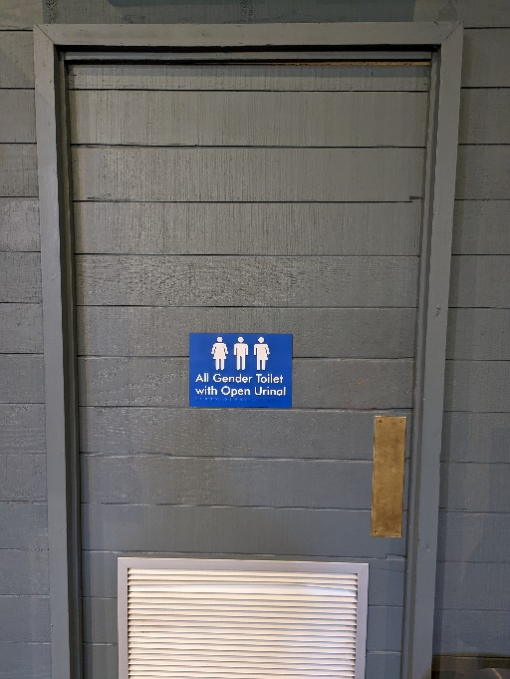
- All Gender Toilet with Open Urinal
- Female Toilet
- All Gender Toilet RH & Baby Change

Beckett Theatre entrance
This entrance is wheelchair accessible.

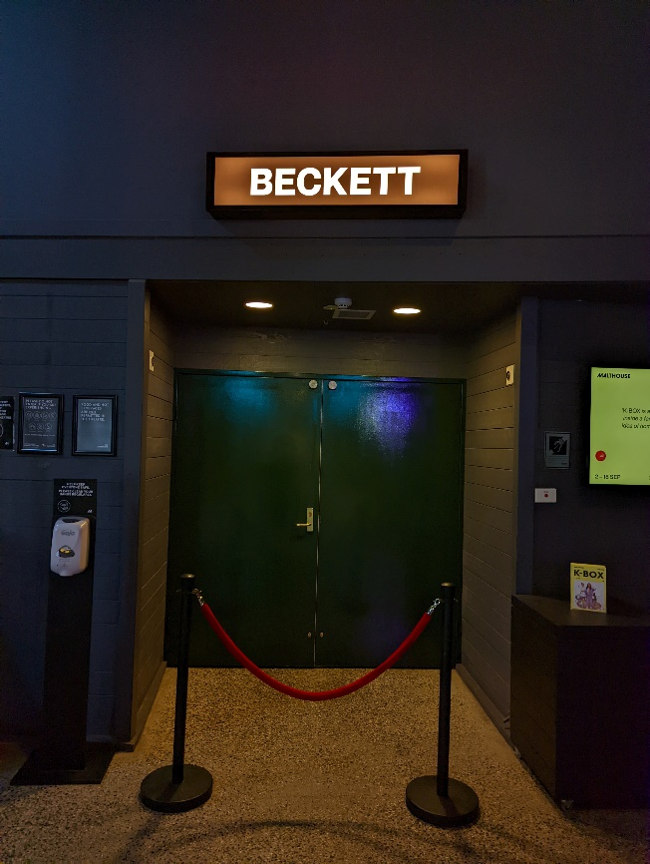
Pictured below: The entrance to the Beckett Theatre

QUIET SPACES

There will be a designated Quiet Space provided. This will be at the back of our other theatre – Merlyn Theatre. A Malthouse staff member can show you where to find the Quiet Space.

The Malthouse courtyard is often a quieter space than inside the building. The courtyard is an outdoor space with seating provided, and tables where you can eat and drink.

Pictured below: The Malthouse courtyard.

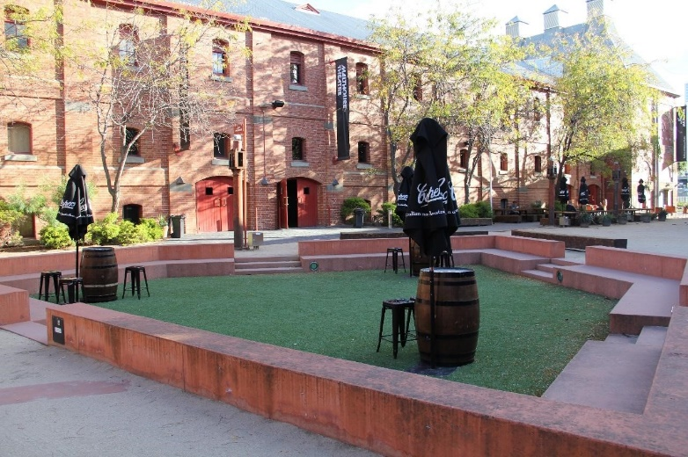

THEATRES
The Malthouse has three theatres, The Merlyn, The Beckett and the Tower Theatre.

Seven methods of killing kylie jenner is playing in the Beckett Theatre which you can enter via the foyer.

All theatres and spaces at the Malthouse are clearly marked. There are many staff members who will be able to assist you if you have any questions.

Seating
- The auditorium seats 175 people.
- Patrons will be seated in the auditorium in assigned seating. This means you can choose your seat when you purchase your tickets.
- Seating is raked from front to back, meaning that patrons in the front row will be on Stage Level, and patrons seated further back will be higher up from the stage.
- The house lights will be on when you enter the theatre.
- There will be an usher present to help you to your seat if you need.
- We have four wheelchair spaces which are in the front row (row A).
- Once everyone is seated, the house lights will be dimmed.
- If you need to leave at any point during the show, please exit through the same door you entered the theatre by. The usher can assist you if needed.
- Latecomers will be admitted at a suitable time at the discretion of the Front of House staff.

Below is a setting map of the Beckett Theatre
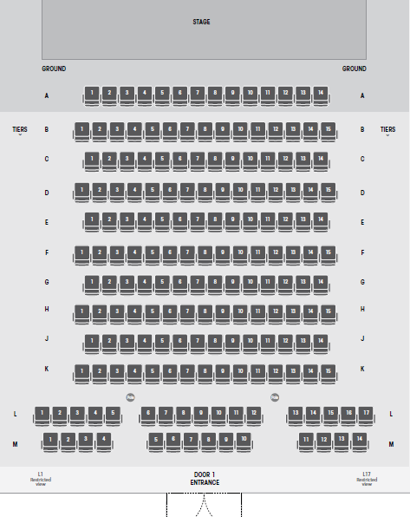

Below is a picture of inside the Beckett Theatre
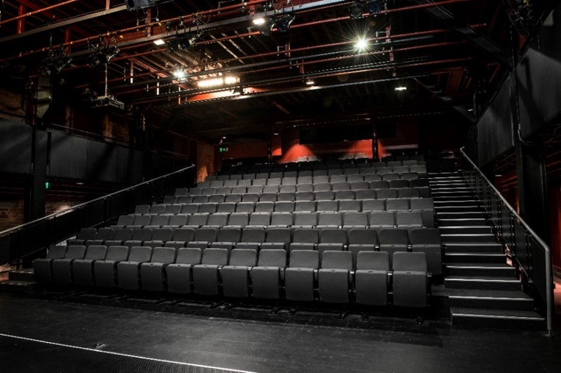

The theatre seats are organized in rows, labelled with letters from A to M. Each seat also has a number on it. Your ticket will show which row and seat number you can sit in.

Pictured below: theatre seats with number labels

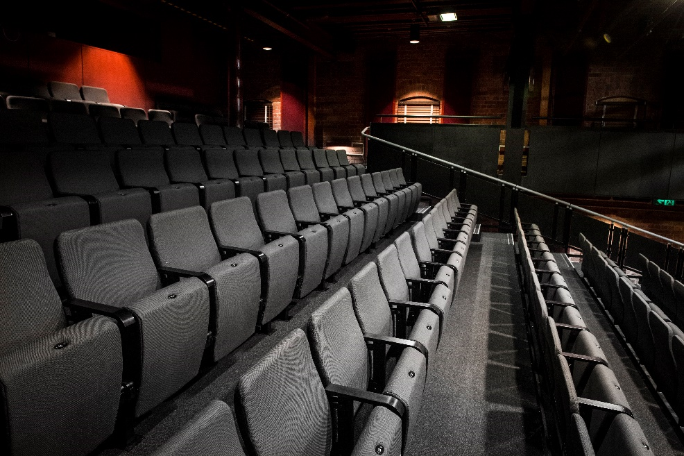

WE’RE HERE TO ASSIST
If you need help finding your seat, or with anything else, you can ask a Malthouse Theatre Usher. Ushers wear a uniform of a black shirt with a lanyard.

Pictured: Usher wearing their uniform.

